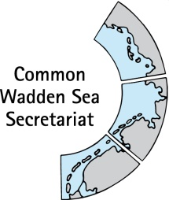
MEETING DOCUMENT
Ad hoc Working Group SWIMWAY (WG-SWIMWAY 20-1)
8 April 2020
Virtual meeting

Agenda Item: 5. SWIMWAY pillar: Policies
Subject: SWIMWAY policy review
Document No.: WG-SWIMWAY 20-1/5
Date: 26 March 20
Submitted by: Martha Buitenkamp

At WG-SWIMWAY 19-1, group members presented short outlines for initiation projects for SWIMWAY. Amongst these, Ms Buitenkamp presented a short outline of a Policy analysis SWIMWAY Wadden Sea. At WG-SWIMWAY 19-3, a first draft policy review for SWIMWAY, compiled by Mr Koolstra (NL), Mr Nick Probst (D) and Ms Vestergaard (DK) has been shared with WG-SWIMWAY. This report summarises existing legislation relevant to the realisation of the fish targets at the European level and the associating implementation in the national law in Denmark, Germany and the Netherlands.
This document contains the second draft policy review, which has been updated by Denmark and substantially reviewed by Ms Buitenkamp.

Proposal: The group is invited to revise and adopt the document and to decide upon next steps.

Trilateral policy review Swimway Wadden Sea

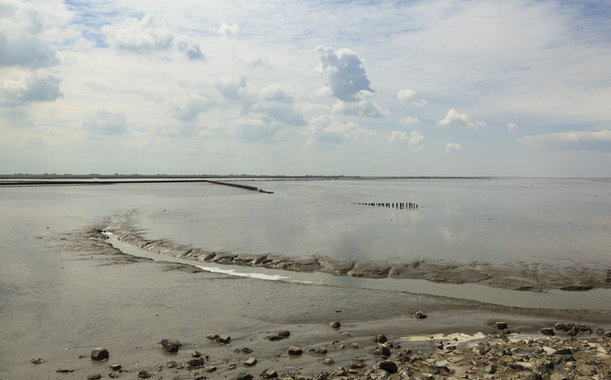
Commissioned by: Programma Rijke Waddenzee

Contents
Summary 4
1 Introduction 5
2 Fish Targets 7
2.1 Introduction 7
2.2 Trilateral Fish Targets vs. Swimway Action Programme 7
3 Birds and Habitats Directive 10
3.1 introduction 10
3.2 Denmark 10
3.3 Germany 14
3.4 Netherlands 16
3.5 General conclusion on the Birds and Habitats Directive 21
4 Water Framework Directive 24
4.1 Introduction 24
4.2 Denmark 24
4.3 Germany 26
4.4 Netherlands 27
4.5 General conclusion on the WFD 30
5 Marine Strategy Framework Directive 31
5.1 Introduction 31
5.2 Denmark 31
5.3 Germany 32
5.4 Netherlands 33
5.5 General conclusion on the MSFD 34
6 EU Eel Directive 35
6.1 Introduction 35
6.2 Denmark 35
6.3 Germany 36
6.4 The Netherlands 36
6.5 General conclusion on the ED 37
7 Common Fisheries Policy 38
7.1 Introduction 38
7.2 Denmark 39
7.3 Germany 40
7.4 The Netherlands 40
7.5 General conclusion on the CFP 41
8 Ballast Water Management Convention 42
8.1 Introduction 42
8.2 Denmark 42
8.3 Germany 42
8.4 Netherlands 43
8.5 General conclusion on the BWM Convention 44
9 Other regulations and agreements 45
9.1 Alien Species Regulation 45
9.2 Maritime Spatial Planning Directive 45
9.3 CITES 45
10 Conclusion and next steps 46
10.1 Conclusion regulation fish species 46
10.2 Conclusion regulation and trilateral fish targets 46
10.3 Next steps 47
Citations 49
Colophon 51

Summary
Many marine and estuarine fish species depend on the Wadden Sea at some point in their life cycle. In recent decades, the populations of many fish species have declined in the Wadden Sea due to largely unknown reasons. As fish are an important part of the Wadden Sea ecosystem, in 2018 the three Wadden Sea countries presented a Trilateral Swimway Wadden Sea Vision, aiming to reach trilateral fish targets for the Wadden Sea (QSR 2009, Wadden Sea Plan 2010). The Swimway vision is described in an action programme Swimway Wadden Sea. This programme contains actions suitable to improve knowledge on relevant processes, optimise population monitoring, adjust policies and develop, realise and evaluate measures to reach the trilateral fish targets.
This report reviews existing legislation relevant to the realisation of the fish targets at the European level and the associating implementation in the national law in Denmark, Germany and the Netherlands. Of the directives, conventions and legislation described, only the Habitats Directive contain specific and concrete measures for habitats and a small group of fish species in the Wadden Sea. Fish species may benefit from the measures aimed at preserving and restoring habitats, but the effect thereof is difficult to estimate. It can be observed, however, that the designation of N2000 areas provides the possibility to limit or even exclude certain (potential) threatening human activities. The Water Framework Directive applies to the 1 mile coastal zone. Here too, targets for specific fish species are often lacking, but much attention is paid to water quality and the removal of barriers, particularly for diadromous fish. With this, the WFD can indeed contribute to the fishing targets, but in the context of this study it is difficult to say to what extent and at what speed this actually happens. The Eel directive has a clear and specific purpose. The measures aimed at removing physical barriers will also help other migrating fish species. The Marine Strategy Framework Directive, the Alien Species Regulation, the Ballast Water Management Convention and the Common Fisheries contribute in an indirect way or in the long term to improvement of fish species.

This report concludes that the link between the trilateral fish targets and the reviewed policies is not very well elaborated. The trilateral fish targets have been formulated at a fairly abstract level and are not accompanied by adequate measures to achieve these targets. This is mostly due to a lack of knowledge. It therefore seems necessary to conduct targeted research into the underlying causes of the decline in fish populations in the Wadden Sea. If the causes of this decline are better known, targeted policies can be developed to resolve these bottlenecks. Now that these bottlenecks are not or insufficiently known, it is difficult to assess to what extent the existing policy is effective. This makes it difficult to encourage policy makers to develop specific fish policy.

Introduction
Many marine and estuarine fish species depend on the Wadden Sea at some point in their life cycle. In recent decades, the populations of many fish species have declined in the Wadden Sea due to largely unknown reasons. As fish are an important part of the Wadden Sea ecosystem, in 2018 the three Wadden Sea countries presented a Trilateral Swimway Wadden Sea Vision, aiming to reach trilateral fish targets for the Wadden Sea (QSR 2009, Wadden Sea Plan 2010).
The Swimway Wadden Sea vision is part of the Leeuwarden 2018 Wadden Sea Declaration and was adopted by the three countries. The Swimway vision is described in an action programme Swimway Wadden Sea. This programme contains actions suitable to improve knowledge on relevant processes, optimise population monitoring, review and adjust policies and develop, realise and evaluate measures to reach the trilateral fish targets.
The outcome of one of these actions, the policy review, presented in this report. It is a diagnosis of the current situation. It shows in what way the current policy and legislation will help to realise the fish targets, and what gaps are still present. The report contains
An analysis of existing legislation and policies that are relevant to the realisation of the fish targets at the European level and the associating implementation in the national law in Denmark, Germany and the Netherlands;
An assessment of the effectiveness of these legislation and policies in helping to realise the fish targets.
The Trilateral Wadden Sea Plan (WSP) is the common policy and management plan for the protection and sustainable management of the Wadden Sea Area. It is also the common management plan for the Wadden Sea World Heritage Site. A unique and basic feature of the Wadden Sea Plan is that it aims at achieving the full scale of habitats, which belong to a natural and dynamic Wadden Sea. Each of these habitats, for which common trilateral Targets have been adopted, needs a certain quality (natural dynamics, absence of anthropogenic disturbance, absence of pollution), which can be reached by proper management of the area. In the Trilateral Wadden Sea Plan (CWSS 2010) the following fish targets have been formulated:
Viable stocks of populations and a natural reproduction of typical Wadden Sea fish species;
Occurrence and abundance of fish species according to the natural dynamics in (a)biotic conditions;
Favourable living conditions for endangered fish species;
Maintenance of the diversity of natural habitats to provide substratum for spawning and nursery functions for juvenile fish;
Maintaining and restoring the possibilities for the passage of migrating fish between the Wadden Sea and inland waters.
The Wadden Sea Quality Status Report 2017 (QSR 2017) on fish (Tulp et al. 2017) describes the status and trends of fish in the Wadden Sea based on several fish monitoring programmes. The QSR 2017 concludes concerning the afore mentioned fish targets of CWSS (2010) the following: “these targets were not formulated in a testable way, which makes it impossible to evaluate them quantitatively”. Furthermore, the formulations are not all easy to comprehend, allowing multiple interpretations. To facilitate an objective evaluation in the future, the Quality Status Report 2017 (QSR 2017) proposes to restructure and reformulate the targets from the Trilateral Wadden Sea Plan as follows:
There should be no human-induced bottlenecks in the Wadden Sea for fish populations or their ecosystem functions. Maintain or improve:
Robust and viable populations of estuarine resident fish species;
The nursery function of the Wadden Sea and estuaries;
The quality and quantity of typical Wadden Sea habitats;
Passageways for fish migrating between the Wadden Sea and inland waters;
Conservation of endangered fish species.

The targets of the QSR 2017 have been incorporated in the Swimway Action Programme (2019). The overall target as mentioned in the QSR 2017 (“There should be no human-induced bottlenecks in the Wadden Sea for fish populations or their ecosystem functions.”) however, is not mentioned in the Swimway Action Programme. Because the targets need to be read and interpreted in the light of the overall target, it will be used in this study.
The next chapter compares the trilateral fish targets with the elaboration of these targets in the QSR 2017 /Swimway Action.
The chapters 3-9 present an overview the relevant European legislation related to the fish targets and (if applicable) their implementation in Danish, German and Dutch legislation. The Birds and Habitats Directive and the Water Framework Directive are the most important, because these directives aim directly at the improvement of the biotic and abiotic quality of habitats and water systems. The Marine Framework Strategy Directive aims at the protection of marine biodiversity, as it contains the explicit regulatory objective that "biodiversity is maintained by 2020", as the cornerstone for achieving Good Environmental Status (GES). Furthermore the Common Fisheries policy, Eel Directive, Ballast Water Management Convention, Aliens Species Regulation, Maritime Spatial Planning Directive and CITES are reviewed in respect of their relevance to fish conservation in de Wadden Sea.
Chapter 10 describes in what way the standing policy supports the realisation of the fish targets. It also addresses the gaps in the policy and suggests what is needed to fill these gaps. Conclusions and recommendations can also be found in this chapter.

Fish Targets

Introduction
Fish are recognised as being an important part of the Wadden Sea ecosystem. The three Wadden Sea nations (the Netherlands, Germany and Denmark) cooperate on fish in the context of the Trilateral Cooperation coordinated by the Common Wadden Sea Secretariat (CWSS) in Wilhelmshaven. This led to co-produced fish chapters in the Quality Status Reports (Vorberg et al., 2004; Jager et al., 2009; Tulp et al., 2017). Derived from the findings in the QSR reports, Trilateral Fish Targets were formulated in the Trilateral Wadden Sea Plan (2010) and these were included in the QSR 2017 in an adapted, testable, formulation. Finally, these targets were embedded in the Swimway Vision, and implemented in a Swimway Action Programme.
All in reference to the overall target: “There should be no human-induced bottlenecks in the Wadden Sea for fish populations or their ecosystem functions.”
Tulp et al. (2017) defined the following recommendations for management:
Stronger support from national governments for fish research. Compared to other more visible and ‘charismatic’ groups such as birds, research on fish is heavily underrepresented and mainly focussed on surveys (rather than research on mechanisms) and on commercial (demersal) species;
Consider that the Wadden Sea is an important (and perhaps critical) area within the entire chain of areas that fish need to complete their life cycle;
Long-lasting trilateral projects are needed to catch up with this backlog;
Facilitate integrated monitoring of fish as part of the food web. Fish is an important component of the food web as food for birds and sea mammals and as predator of benthos and lower trophic levels;
Management of the Wadden Sea should be at (inter)national levels instead of provinces;
Exploring the possibilities of citizen science (as currently in practise in daily emptying of the NIOZ fyke) or cooperation with fishermen could enhance research effort;
Map quality and quantity of typical Wadden Sea habitats (saltmarshes, shellfish reefs, seagrass beds, mudflats, sandflats) to reconcile conservation with other stakes (spatial planning).

Trilateral Fish Targets vs. Swimway Action Programme
The Wadden Sea fish populations are composed of a diverse species mix, with altogether 162 recorded fish species. The functions that the Wadden Sea fulfils for those species may differ.
Wadden Sea fish targets were formulated for the first time in 2010. The formulation was such, that implementation was not straightforward. The targets were rephrased in the Quality Status Report of 2017. In the Swimway Action Programme (Feb 2019), another attempt was made to make the targets more concrete. However, it was concluded that more specific objectives for fish were not possible at this stage, given the lack of understanding on the functioning of the Wadden Sea ecosystem for fish and the key processes driving the fish populations.
The Swimway Action Programme aims at identifying population bottlenecks and the translation of this knowledge into effective management and conservation measures.
The programme includes the policy analysis, which is the topic of our fore lying work..The QSR 2017 states that the Fish Targets (incorporated in the Swimway Action Programme) should “facilitate an objective evaluation in the future”. In the table below, the Trilateral Fish Targets and the corresponding targets as formulated in the Swimway Action Programme are listed, and remarks are made based on the comparison of both.

Trilateral Fish Targets | Swimway Action Programme | Remarks
Viable stocks of populations and a natural reproduction of typical Wadden Sea fish species. | Maintain or improve:  Robust and viable populations of estuarine resident fish species. | Typical fish communities in the Wadden Sea include as also juvenile fish of marine species, marine seasonal visitors, diadromous species and even freshwater species that are indicative of an undisturbed estuarine gradient
Occurrence and abundance of fish species according to the natural dynamics in (a)biotic conditions. | Maintain or improve:  Conservation of endangered fish species | The trilateral target was formulated more widely, included all fish species occurring in the Wadden Sea, not only those that are endangered
Favourable living conditions for endangered fish species. | Maintain or improve:  The quality and quantity of typical Wadden Sea habitats. | It is not only the habitats but also water quality (oxygen)
Maintenance of the diversity of natural habitats to provide substratum for spawning and nursery functions for juvenile fish. | Maintain or improve:  The nursery function of the Wadden Sea and estuaries. | Nursery function (in Swimway) is more limited than the Trilateral target, which includes spawning and nursery function
Maintaining and restoring the possibilities for the passage of migrating fish between the Wadden Sea and inland waters. | Maintain or improve:  Passageways for fish migrating between the Wadden Sea and inland waters. | Both targets are similar

Table 1 Summary of the Wadden Sea fish targets, formulated in 2010 (Trilateral Fish Targets) and rephrased in 2017 (QSR 2017) and a comparison of both.
Based on the comparison in the table above, we can conclude that the targets as described in the CWSS 2010 and the QSR 2017 are comparable and not contradicting the Swimway targets in any way. This means that the policy review will encompass both the CWSS 2010 and the QSR 2017 by assessing these targets.

Birds and Habitats Directive

introduction
The Habitats Directive (Council Directive 92/43/EEC) promotes the maintenance of biodiversity, taking economic, social, cultural and regional requirements into account. It forms the cornerstone of Europe's nature conservation policy with the Birds Directive and establishes the EU wide Natura 2000 ecological network of protected areas, safeguarded against potentially damaging developments.
The HD aims at the conservation of a wide range of rare, threatened or endemic animal and plant species. Around two hundred rare and characteristic habitat types are also targeted for conservation in their own right and described in Annex I of the HD. For the protection of these habitats Special Areas of Conservation (SAC’s) should be installed. Annex II of the HD contains a list of animal and plant species of community interest whose conservation requires the designation of SAC’s. Annex IV contains a list of animal and plant species of community interest in need of strict protection.
The Birds Directive aims at the protection of (all) European bird species. The protection of Special Protection Areas (SPA’s) as stated in the Birds Directive has been incorporated in the Habitats Directive since June 10th 1994.

Denmark
The Habitats Directive is implemented in the Danish national law as a part of Environmental Targets Act (Miljømålsloven) and Nature Protection Act (Naturbeskyttelsesloven). The Danish government is responsible for designating Natura 2000 sites in Denmark and in 1998, the Danish habitat areas covered by the HD designated. Thus, most of the Danish Wadden Sea is covered by Natura 2000 sites. To meet the BD and HD requirements, a basis analysis of each Natura 2000 site is carried out every sixth year, providing the data needed in order to plan the upcoming six years. The next analysis will be done in 2020.
The Danish Wadden Sea includes four habitat areas (H78, H86, H90 and H239), which contains several relevant habitat types Annex I. The Danish Wadden Sea contains seven fish species included in Annex II. Only Houting is listed in Annex IV.

HD Element | H78 Ribe Å, Tved Å and Varde Å west of Varde | H86 Brede Å | H90 Vidå with inflow, Rucbøl Sø and Magisterkogen  F57 Vadehavet | H239 Alslev Ådal
Habitat types
1110 Sandbanks which are slightly covered by seawater all the time. | Yes | No | No | No
1130 Estuaries. | Yes | No | No | No
1140 Mudflats and sandflats not covered by seawater at low tide. | Yes | No | No | No
1150 Lagune | Yes | No | No | No
1160 Large shallow inlets and bays. | Yes | No | No | No
1170 Reefs. | Yes | No | No | No
1310 Salicorna and other annuals colonizing mud and sand. | Yes | No | No | No
1320 Spartina swards. | Yes | No | No | No
1330 Atlantic salt meadows. | Yes | No | No | No
3150 Nutritious Lake | Yes | No | Yes | Yes
3260 Streams | Yes | Yes | Yes | Yes
Species
1095 Sea Lamprey (Petromyzon marinus) | Yes | No | Yes | Yes
1096 Brook Lamprey (Lampetra planeri) | Yes | Yes | Yes | Yes
1099 River Lamprey (Lampetra fluviatilis) | Yes | Yes | Yes | Yes
1103 Twaite shad (Alosa fallax) | Yes | No | No | No
1106 Salmon (Salmo Salar) | Yes | No | No | Yes
1113 Houting (Coregonus oxyrinchus) | Yes | Yes | Yes | Yes
1145 Weatherfish (Misgurnus fossilis) | No | No | Yes | No

Table 2: Habitat and species elements in relevant Danish Wadden Sea areas
On a national scale, a consolidation act pursuant to the Nature Conservation Law focuses on conservation of specific animals and plants: Statutory Order on the Protection of certain Animal and species and the care of injured wild-life (Bekendtgørelse om fredning af visse dyre- og plantearter og pleje af tilskadekommet vildt). The act prohibits all kinds of capture and killing of species covered by the Annex IV.
The HD is likewise a part of the Statutory Order on protection and wild-life sanctuary in the Wadden Sea, focussing directly on conservation (Bekendtgørelse om fredning og vildtreservat I Vadehavet). The aim of this act is to promote sustainable management of the Wadden Sea and to ensure fulfilment of Denmark’s international obligations in relation to the Habitats Directive, the Birds Directive and the Ramsar Convention. The act provides strict regulations prohibiting commercial fishing for shellfish and fish. Dispensation can be given in a few smaller areas for exploratory fishing; however this has been the case for some 14 years, now leaving the Danish Wadden Sea rather pristine compared with the German and Dutch parts of the area. Watersport activities are also under strict regulation, and water activities are only allowed in specific areas during a specific time of the year. In some areas the public is not allowed access at all at any time during the year. The act is currently under revision and is expected to be even stricter in the future.
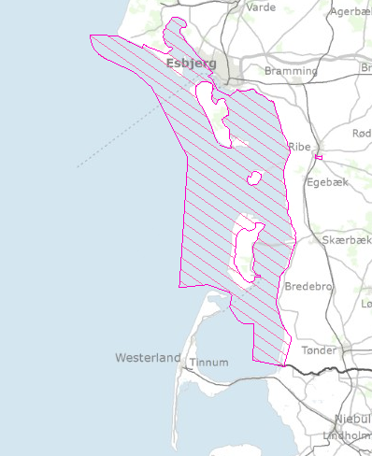

Figure 1 The area protected by Statutory order on protection and wild-life sanctuary in The Wadden Sea

The Danish Wadden Sea is also a designated national park called “Nationalpark Vadehavet”, which opened in 2010. The general legislation behind the national parks does not introduce any new binding formal management – and/or protection regimes. A board appointed by the Minister of Environment leads the national park. The board consists of stakeholders from organisations with different interests in the Wadden Sea. The national park is the biggest in Denmark and extends over four different municipalities; Esbjerg, Fanø, Tønder and Varde.

Issues with the conservation states of habitat types and species
The Ministry of Environment controls the Natura 2000 sites and the assessed status of HD elements is determined here. In site 89 or 86? Wadden Sea, the majority of the areas are determined to be in a moderate to a good condition. The other habitats were not yet assessed. A general system for assessing the state of the marine nature types has not yet been developed, but especially nutrient loads and anthropogenic activities are expected to have an impact. Nutrient load is among several stressors that are not included in the basis analysis. Such stressors are expected to have an impact on both species and the state of the habitats.
The basis analysis evaluates some possible threats to the habitat types present in the Wadden Sea. Among these are direct impacts from agriculture, invasive species and fisheries. The pacific oyster (Crassostrea gigas) is considered a permanent species in the Wadden Sea, and some scientist regard the pacific oyster and other mussels as coexisting. It is not legal to perform commercial fishing for the pacific oyster in the Danish part of the Wadden Sea, but for private use, you can collect them applying manual collection only. An issue predicted and feared is the Signal Crayfish, which is an invasive species that carries crayfish plague. The Ministry of Environment and Food Security is currently making a guideline on how to handle the Signal Crayfish and how to prevent it from spreading further, and minimize the risk of Crayfish plague.
Despite the tight restrictions on fisheries in the Danish Wadden Sea, there are still fishing activities in the outer (North Sea) part of the Wadden Sea and in the adjacent marine area (see figure 2). It is especially the bottom trawling fishery activities that is expected to affect the habitats and species (Naturstyrelsen, Miljøministeriet, 2013).

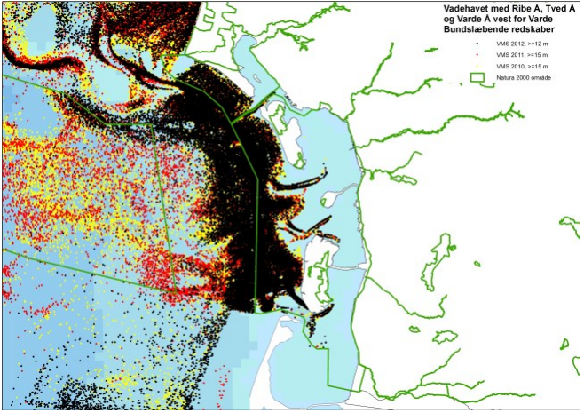

Figure 2: GPS tracking of fishing vessel with bottom trawling equipment (Naturstyrelsen, Miljøministeriet, 2013).

Based on criteria for favourable conservation status, the only fish found in the Danish Wadden Sea with a favourable status is the Brook Lamprey (Lampetra planeri). The difficulties of monitoring fish species, and the fact that there’s no general Danish monitoring programme directed towards non-commercial species might be an issue in relation to the conservation state. The brook lamprey is an example hereof. It is habituated in shallow, muddy and slowly flowing water which makes detection by electrofishing difficult. Other species such as Salmon have a limited distribution in Denmark due to its high demands for habitat quality. The conservation status of the Salmon is unfavourable, as is the status of the European Weatherfish (misgurnus fossilis). The Houting is of high concern in the Wadden Sea. The breeding and thus survival of the Houting is dependent on having access to the larger streams that flow into the Wadden Sea. The poor swimming skills puts a limit to its movement, and if a stream provides fish ladders or other obstacles, the conservation state of the Houting can be affected. According to the assessment of conservation status, the Houting is uncertain. The population has been declining throughout the past century, and in order for the species to be in a favourable state, it needs to be increasing (Søgaard et. al, 2007).
Climate change is another factor that is suspected to have a negative impact on the marine life in the Wadden Sea. Through higher water temperature breeding shellfish might be impacted negatively and some marine species might migrate to cooler waters.

Conclusion
In general there is a lack of restrictions aiming directly at conservation of fish species. Marine species other than those covered by the HD will primarily be affected indirectly through the different laws and acts that are based on the directives. The fish populations in the Wadden Sea depend to a high degree on the quality of the habitat types, which is why conservation and management hereof is important. The national law already provides strict regulations on human activities such as fisheries.

Proposed solutions
As the inner Danish Wadden Sea is the best protected part of the Wadden Sea in general - de facto prohibiting fishery there during the last 14 years-, an ongoing revision of the Statutory Order protecting the area however also deals i.a. with the consequences of the basic possibility that still exists of fishery when certain biological conditions are met taking into account. In this connection recent knowledge of i.a. biotopes and food web interconnectivity is being taken into consideration.

Germany
The Habitats Directive was implemented into German national law as part of the “Bundesnaturschutzgesetz” in 1998. The governments of the federal states are responsible for designating Natura2000 sites in the German coastal seas (up to 12 nm from the coast baseline), the federal government implements the Natura2000 sites in the German exclusive economic zone (EEZ). The Wadden Sea is therefore predominantly covered by Natura2000 sites of the federal states Niedersachsen, Hamburg and Schleswig-Holstein. The German Wadden Sea is also managed as a national park, split into three administrative entities run by the aforementioned federal states. The relevant HD elements for each federal state are listed in table 3.

HD element | Niedersachsen | Hamburg | Schleswig-Holstein
Habitat types
1110 Sandbanks which are slightly covered by seawater all the time | Yes | Yes | Yes
1130 Estuaries | Yes | Yes | Yes
1140 Mudflats and sandflats not covered by seawater at low tide | Yes | Yes | Yes
1160 Large shallow inlets and bays | Yes | Yes | Yes
1170 Reefs | Yes | No | Yes
1310 Salicorna and other annuals colonizing mud and sand | Yes | Yes | Yes
1320 Spartina swards | Yes | Yes | Yes
1330 Atlantic salt meadows | Yes | Yes | Yes
Species
Sturgeon Acipenser sturio | Yes | Yes | Yes
Houting Coregonus maraena | Yes | Yes | No
Sea lamprey Petromyzon marinus | Yes | Yes | Yes
River lamprey Lampetra fluviatilis | Yes | Yes | Yes
Twaite shad Alosa fallax | Yes | Yes | Yes

Table 3 Relevant HD elements for the three federal states

Issues with the conservation state of habitat types and species
The assessed status of HD elements differs between the federal states, but results from Schleswig-Holstein from 2013 for example show that in the Atlantic region of Schleswig-Holstein, the conservation status of only four habitat types has been assessed as “favourable”, for 45 habitat types the conservation status has been assessed as unfavourable – inadequate or unfavourable – bad (four habitat types were not assessed). In the same region, the conservation status of only 11 out of 46 species has been assessed as “favourable”.
The main reasons for the unfavourable assessment outcomes of habitat types were attributed to eutrophication, contamination by herbicides and pesticides and disturbances of hydrological regimes e.g. through measures of coastal defence. For fish species the main reason of unfavourable conservation statuses was related to the lack of connectivity in freshwater systems i.e. the obstruction of migration pathways.
The HD directive does not provide any jurisdictional means to implement measures which are directly designated to protect marine fish species listed in Table 3 (apart from the diadromous species). A major shortcoming of the HD is the neglect of other marine fish species.
The management measures of the Natura2000 sites within the German Wadden Sea restrict fishing to only small extent. Fishing on brown shrimp Crangon crangon with small beam trawls of ~ 7 m beam width is allowed in wide parts of the national park (i.e. also within the Natura2000 sites). Beam trawling for shrimp is causing high rates of bycatch and discards of juvenile fish, mostly of juvenile flatfish and crustaceans (Ulleweit et al. 2010). Attempts to restrict shrimp trawling within the Wadden Sea have not been successful, as the impacts of the bycatch and discarding practices on the affected populations are not well understood and subject of debate. While plaice is discarded in high amounts, survival rates are unknown and the North Sea plaice stock in general is exceptionally large. Thus, the pressure of the shrimp beam trawl fisheries on the plaice stock does not appear to be essential.
The production of blue mussel Mytilus edulis is a mixture of wild fisheries and aquaculture. Wild mussels are dredged as seedlings from designated areas and brought to grow-up areas, where they are harvested one or two years later at a minimum size of 4 cm. The dredging of mussels is considered as a detrimental activity on benthic habitats and is thus regulated and limited by a management plan endorsed by license holders, the government of Niedersachsen and environmental agencies. The extent of sublittoral mussel beds is still unknown, but the impact of the dredging on mussel seedlings is only allowed in strictly designated sites amounting to less than 1% of the available sublittoral area of Niedersachsen (Anonymous 2017).
Other human activities exerting pressure on the fish communities of the Wadden Sea are not as widespread as fishing, but include shipping, sludge deposition from river deepening (Elbe, Ems) (BLANO 2018).

Proposed solutions
More environmental-friendly beam trawling techniques for shrimp along with designation of no-take zones may allow to improve the conservation of the HD habitats 1110 and 1130. The increased use of spat collectors in the blue mussel seedling fisheries should improve the conservation of HD habitats 1140, 1160 and 1170. The harvest and cultivation of blue mussels is co-managed between the federal state of Niedersachsen and the fishing companies.

Netherlands
The Birds and Habitats Directive are fully implemented in the Nature conservation act (Natuurbeschermingswet, Wnb). The Nature Conservation Act protects Natura 2000-sites (area conservation, with the qualifying habitats and species for which the site is designated). The part of the Nature Conservation Act that protects species listed in Annex IV of the Habitats Directive (species conservation) is relevant for this study, but the only marine fish species listed on Annex IV are the Houting and Sturgeon, which are very rare and seldom present in the Wadden Sea.
With respect to the area conservation chapter of the Nature Conservation Act, the Wadden Sea is designated as a SPA and SAC. In the Netherlands, the term Natura 2000-site is commonly used to describe both a SAC and a SPA.
Three fish species, as listed in Annex II of the Habitats Directive, have been assigned as conservation targets in the Natura 2000-area Wadden Sea. These are:
S1095 Sea lamprey (Petromyzon marinus);
S1099 River lamprey (Lampetra fluviatilis) and;
S1103 Twaite shad (Alosa fallax).
A large number of habitats have been assigned a conservation status in the Wadden Sea Natura 2000-site, of which three are relevant for the protection of fish in the Natura 2000-area Wadden Sea. Those habitats are:
H1110A (permanently covered sand flats);
H1140A (tidal flats) and;
H1130 (estuaries).
For each of these habitat types, selected fish species have been listed as elements that contribute to the quality of the habitat (typical fish species).
Typical fish species of H1110A (permanently covered sand flats)
For H1110A these are: Hooknose Agonus cataphractus, Fivebearded rockling Ciliata mustela, Herring Clupea harengus, Dab Limanda limanda, Sea snail Liparis liparis , Bullrout Myoxocephalus scorpius, Butterfish Pholis gunnellus, Flounder Platichthys flesus, Plaice Pleuronectes platessa and Eelpout Zoarces viviparus (Profielendocument H111A permanent overstroomde zandbanken (getijdengebied), versie 2014).

Typical fish species of H1140A (tidal flats)
For H1140A these are: Plaice Pleuronectes platessa, Flounder Platichthys flesus, Mullet Mugil labrosus (Profielendocument H1140 bij eb droogvallende slikwadden en zandplaten, versie 2008).
Typical fish species of H1130 (estuaries)
For H1130 these are: Anchovy Engraulis encrasicolus, Flounder Platichthys flesus, Pipefish Syngnathus acus and Syngnathus rostellatus, Hooknose Agonus cataphractus, Whiting Merlangius merlangus and Bullrout Myoxocephalus scorpius (Profielendocument H1130 estuaria, versie 2008).
.
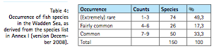
Altogether these fish species comprise about 10% of the total of 150 fish species that have been recorded as occurring in the Wadden Sea (Jager et al., 2009; see “Table 4”).
Natura 2000 Management Plan
The Dutch Natura 2000 Management Plan of the Wadden Sea 2016-2022 (I&M 2016) contains the conservation measures needed to reach the favourable conservation state of all qualifying habitats and species of the Wadden Sea. Because only a limited number of fish species is a qualifying Natura 2000 species (Sea lamprey, river lamprey and Twaite shad) most of the fish species will have no conservation measures specifically targeting these species. This means most fish species have to profit from conservation measures aimed at the conservation of the marine habitats. Other measures in the management plan concern knowledge development, which may lead to more effective measures in the future.

The Management plan describes the following conservation measures relevant for the above mentioned habitats and species:
H1110A Permanently covered sand flats
In the Wadden Sea, habitat type "permanently covered sand flats" can be found in trenches and permanently flooded plains. These areas are often indicated as the "sublittoral". The channels can be found throughout the Dutch Wadden Sea, from the small gullies between the tidal flats to the wide tidal inlets between the islands. The permanently flooded plains lie mainly north of the Afsluitdijk, as a remnant of the former Zuiderzee. On the flooded plains the current velocities are lower than in the channels and in many places on the flooded plains, the water is so deep that the effect of wave action on the soil is small, so that the soil is fine sandy to muddy in many places. Because of this, the bottom fauna in the shallower water surfaces of the western Wadden Sea is richer than in the channels. Locally, hard substrates such as shell banks and areas with peat, boulder clay or stones are present. In addition, also hard substrates are formed by organisms in the form of oyster beds and mussel beds. It is the habitat for algae, shellfish, tube worms, sea urchins, shrimp, crabs and fish.
Before the Natura 2000 management plan came into effect, the mechanical cockle dredging in the Netherlands was ended. This may have had a positive impact on the sea bed (less disturbance) of the sub littoral (H1110A). This is an example of the effectiveness of the Habitats Directive, as the mechanical shellfish fishery was ended by court ruling based on the Habitats Directive.
Issues with the conservation state
The state of conservation of "permanently flooded sandbanks" in the Wadden Sea has been assessed as moderately unfavourable. This assessment is mainly based on the limited occurrence of sublittoral mussel beds in mainly older stages of development and at the strongly reduced total biomass of fish and the reduced bottom life community and nursery function / growing area for fish. The unfavourable assessment can also be the result of various forms of soil agitation. Changes in natural factors (climate change) and the closure of the Zuiderzee in the last century may also play a role. It is suspected that climate change, through the occurrence of warmer winters (higher sea water temperature), has a negative impact on the breeding of shellfish and results in certain fish species migrating from the Wadden Sea to the North Sea in an earlier stage. The beam trawling in the North Sea may have a negative impact on the composition of the fish populations in the Wadden Sea, but this effect is unclear. There is also a limited gradient in salinity, as a result of which there is limited fish migration and locally slightly impoverished fauna at freshwater discharge points.
Proposed solutions
An improvement in the quality of "permanently flooded sandbanks" (with sublittoral mussel beds in older stages) can possibly be achieved by continuing the phasing out of mussel seed fishing from the bottom (transition process via spat collectors (MZIs in Dutch) and/or other innovative methods), as well as by (further) making the shrimp fishing more sustainable (reduction of bycatch and protection of benthic communities). Opportunities for the development of multi-annual sublittoral mussel beds are present in the western Wadden Sea, because mussel spat falls naturally in this part of the Wadden Sea. The experiments with the development of the mussel beds have positively contributed to the necessary knowledge on the development of mussel beds. Research into the causes of the fish biomass decline in the Wadden Sea is needed. Monitoring the development of fish stocks and conducting more research may help to understand processes that cause decline in fish abundance until the next management plan period.
H1140A Tidal flats
The Wadden Sea is the most important area in the Netherlands for this habitat type, which is also referred to as the "littoral" or the tidal area between high and low water. It is a very dynamic habitat type of which the exact location and the surface area change annually due to erosion and sedimentation processes. In addition to the rich bottom fauna, littoral (dry-falling) mussel beds and seagrass (fields) are of great importance for foraging birds. On many mussel beds nowadays also the Pacific oyster (Crassostrea gigas) is present. This species is an exotic species established in the entire Dutch Wadden region between 1983 and 1999. It often occurs in mixed beds with blue mussels. Other littoral mussel species such as blue mussels (Mytilus edulis) appear to develop well in oyster beds. The mussel and oyster beds (including mixed forms) make up no more than 1.5 - 3 percent of the tidal flats.
Recent research shows the importance of mussel beds to be greater than suspected, due to the impact of the banks on the surrounding mudflats (with more sludge deposition). The drifting area therefore largely consists of mudflats of sand and sludge, often with a rich benthic life underneath (amongst others: cockles, knife heads, soft-shell clams, worms).
Issues with the conservation state
At the moment, the areal extent of sublittoral mussel beds and the associated living communities is insufficient. Although the soil agitation has been reduced, the natural restoration of the littoral mussel beds in the western Wadden Sea is so far still lagging behind that in the eastern Wadden Sea. Recent monitoring (2006-2011), however, shows there is a (slightly) increased establishment of mussels on Japanese oyster beds. How the symbiosis between oyster and mussel beds develops is still uncertain. Climate change might have an adverse effect on the further recovery of the littoral mussel beds. The higher seawater temperature is suspected to be detrimental to the breeding of shellfish, including mussels, and it may cause an increase of prawns, which predate on juvenile mussels. Furthermore, there are too few seagrass meadows for a good quality of the habitat type. The sublittoral sea grass morphs have altogether disappeared from the Dutch Wadden Sea and the current conditions seem unfavourable for recolonisation. The sea grasses that are still present are the littoral form of Zostera marina and the small eel grass Zostera nana.
Proposed solutions
Experiments with stimulating development of seagrass fields (and ruppia fields) can contribute to a positive development of the quality of the habitat type tidal flats. However, the success of restoration of sea grass fields is uncertain at this moment and it is unsure if and when it will have a positive impact on the fish populations in the Wadden Sea.
In projects such as “Mosselwad” and “Waddensleutels” research is carried out (with field tests) on the influences of hydrodynamics and climate change on opportunities for and threats to mussel beds. Based on these studies the conclusion can be drawn that little else is possible in this natural system than protecting (young) mussel beds from human activities. In the long term, mussel beds may then possibly develop into older stable structures that can maintain themselves better. Moreover, more natural salinity gradients are desired by adapting the management of fresh water discharge points. Furthermore, research into sediment and sludge management in the Wadden Sea, by Rijkswaterstaat as a WFD measure, is important (knowledge building).
H1130 Estuaries
This habitat type comprises both the littoral and sub littoral parts of the Ems-Dollard Estuary. The Natura 2000 Management plan of the Wadden Sea does not contain any information on this habitat type, because it is only a qualifying habitat type in the Natura 2000 site “Eems-Dollard” for which a Management plan is not yet available.
S1095 Sea lamprey (Petromyzon marinus), S1099 River lamprey (Lampetra fluviatilis) and S1103 Twaite shad (Alosa fallax)
These three fish species are anadromous, which means that these species migrate from the marine environment to inland waters to spawn there. An important part of their life cycle is at sea and the Wadden Sea and in particular the Wadden Sea estuaries are of great importance for these species.
Issues with the conservation state
The national trend data for the Sea lamprey are unclear, the data of the River lamprey shows an upward trend. In the past few decades there seems to be a positive one trend for the Twaite shad. The presence of barriers in the form of dams and locks, hamper the migration of these fish to the rivers and vice versa. Furthermore, the presence and quality of upstream spawning grounds for the Lampreys (and the Twaite shad) may be insufficient. In the Natura 2000 management plans of, among others, the Drentsche Aa and Gelderse Poort, both areas with conservation objectives for river and / or sea lamprey, suitable spawning grounds must be provided. Regarding the Twaite shad, it is likely that the conditions (light current, sufficiently good water quality for supply of eggs, the presence of tides) in the spawning grounds located in Germany are insufficient. There is a high degree of turbidity in the Ems and the water is sometimes anoxic, and the river has been channelized to a large extent with little remaining spawning habitat. Within the Wadden Sea (including Ems Dollard) there is no spawning or nursery area for the Twaite shad. Furthermore, in the current situation there are hardly any suitable and accessible estuaries for the Twaite shad in the Netherlands. (There is evidence of successful Twaite shad reproduction in the Scheldt estuary). Juvenile Twaite shads are sometimes encountered in the Dutch coastal waters and in the Wadden Sea, but it is not known from which spawning sites these individuals originate.
Proposed solutions
For an increase in the population of the Lampreys an unobstructed migration from the Wadden Sea to the inland spawning areas is needed, together with an improvement of the habitat quality of the spawning areas. To facilitate the migration of the Twaite shad on the Ems river, the suspended sediment concentration in the water needs to be lowered. These measures will be added to the management plan after the designation of the Ems-Dollard as a Special Area of Conservation.
Conclusion
The fish populations of the Wadden Sea depend on good habitat quality. The Natura 2000 management plan of the Wadden Sea should lead to a favourable conservation status of habitat types H1110 A, H1140A and (in the future, after the Ems-Dollard has been designated as a SAC) H1130. This should lead to a better habitat quality for the fish populations. However, looking at the sixty measures proposed in the Wadden Sea Natura 2000-management plan (see management plan table 8.6), it must be concluded that it contains hardly any measures from which the fish populations will benefit directly. Only the following measures might (in time) have a positive impact on fish populations:
change from mussel seed fisheries to MZI’s (an installation used to harvest mussel seeds without disturbance of the seabed);
change to a more sustainable way of shrimp fisheries (less bycatch of fish, less disturbance of the seabed);
restoration of sea grass fields (success very uncertain)
knowledge development on the development of mussel beds
knowledge development on the reduction of turbidity.
The management plan contains no explicit measures to enhance the water quality, enlarge the abundance of food for fish, reduce the turbidity, etc. It seems as if fish, as an important part of these habitat types, have been overlooked, or at least have gotten little attention.

General conclusion on the BHD
The Birds and Habitats Directives provide very limited protection for marine fish species in general. The Nature 2000 sites are designated to conserve habitats, but not specific fish species, except the limited number of fish species for which specific conservation targets have been set (fish species of Annex II). Conservation measures aimed at these species are however scarce. It is hard to say whether the indirect protection by the designation of habitats protection areas, suffices for marine fish species.
The number of fish species for which Annex IV requires protective measures is limited. The impact at non-protected species is unknown.
The comparison between the three countries in table 4 shows that the designation of habitats differs. This is partly due to physical differences and partly caused by a different designation policy: the Danish Wadden Sea encompasses two fresh water habitats ( 3150 and 3260) and two fresh water fish species (1096 and 1145).
Habitat | DK | G | NL
Sandbanks (1110) | x | x | x
Estuaries (1130) | x | x | x
Mudflats and sandflats not covered by seawater at low tide (1140) | x | x | x
Lagune (1150) | x
Large shallow inlets and bays (1160) | x | x
Reefs (1170) | x | x
Salicorna and other annuals colonizing mud and sand (1310) | x | x | x
Spartina swards (1320) | x | x | x
Atlantic salt meadows (1330) | x | x | x
Nutritious Lake (3150) | x
Streams (3260) | x

Table 4 Comparison Habitats designation Relevant HD elements for the three federal states

Table 5 shows a comparison the assigned fish species per country.
 | DK | G | NL
1095 Sea Lamprey (Petromyzon marinus) | x | x | x
1096 Brook Lamprey (Lampetra planeri) | x
1099 River Lamprey (Lampetra fluviatilis) | x | x | x
1103 Twaite shad (Alosa fallax) | x | x | x
1106 Salmon (Salmo Salar) | x
1113 Houting (Coregonus oxyrinchus) | x | x
1145 Weatherfish (Misgurnus fossilis) | x
Sturgeon (Acipenser sturio) |  | x

Table 5 Comparison protected Fish species

The Danish “Statutory order on protection and wild-life sanctuary in The Wadden Sea” makes it possible to protect the entire Danish Wadden Sea area as commercial fishing, in general, is not allowed. Only one dispensation is given to perform exploratory fishing during the last 12 years. In addition, water activities are strictly managed to protect the marine life as well as birds in the area, like traffic on land (both pedestrians, bikes and cars are only allowed in certain areas as well.
The German designated Natura2000 sites do not restrict human activities.
The Dutch Natura 2000 management plan regulates current (economical) activities in the Natura 2000-site, restoration projects, management activities, but hardly contains measures with a direct positive impact on fish populations.

Water Framework Directive

Introduction
The Water Framework Directive (WFD), which was introduced in 2000, commits the EU member states to achieve good qualitative and quantitative status of all water bodies, including marine waters up to one nautical mile from shore. The quality status of water bodies is assessed based on the hydro morphological, physical-chemical and biological quality (fish, benthic invertebrates, aquatic flora). The aim is to reach the good ecological status in case of natural water bodies and a good ecological potential in case of heavily modified water bodies.

Denmark
The WFD was implemented in Denmark in 2002 within the Water Planning Act (Lov om Vandplanlægning). Denmark is divided in river basin units and these are further divided into head-water-catchments. The law also ensures that a basis analysis of each river basin unit is prepared. As for transitional waters, lakes and streams the ecological status has a biological quality element that describes fish fauna. This is not the case for the coastal waters. Here, the ecological state depends on factors such as eel grass, chlorofyll a, benthic fauna and pollutants. In figure 3 below the state of the Danish Wadden Sea is shown, though not all quality elements have been assessed. The map indicates that no coastal area in the Wadden Sea is in good ecological condition.

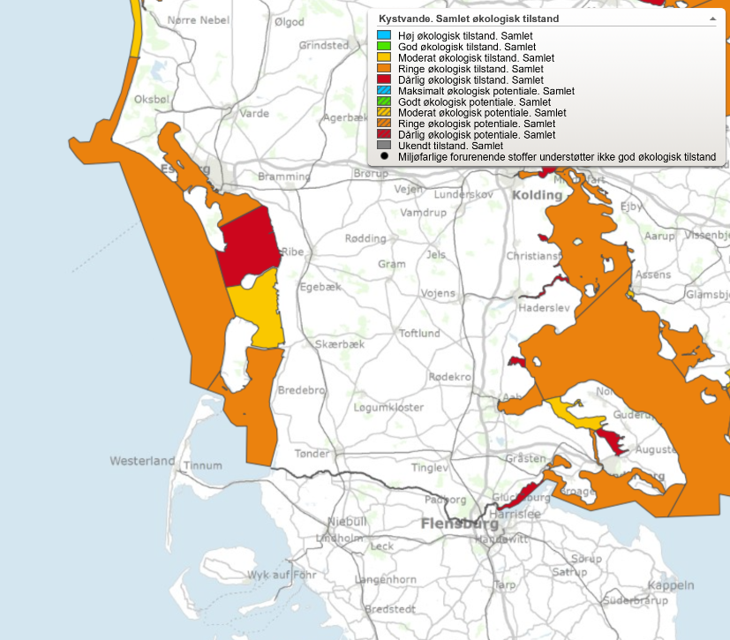
Figure 3. Overall ecological status of Water bodies in the Danish Wadden Sea. Yellow: Moderate condition, Orange: Poor condition, Red: Bad condition (Source: Miljøstyrelsen, N.D.)

The creeks Vidå, Bred å, Ribe å, Kongeå, Sneum å and Varde å are connected to the Danish part of the Wadden Sea. The ecological state here depends as mentioned on fish fauna among others. A population’s density and composition should be almost equal to that of an untouched population in order to be in a good condition. Of course, it is likely that actions taken to improve the state of the streams will also influence the coastal community. The plan for the Wadden Sea from 2009-2015 included aims such as reducing the nitrogen emission to the environment in the catchment area and improving the physical conditions of water bodies. For the coastal areas specifically a reduction of nutrients was required (Naturstyrelsen, 2011). Such measures should improve the living conditions for fish too.

Germany
The WFD was implemented in Germany within the “Wasserhaushaltsgesetz” in 2002. Though the WFD includes coastal waters up to 1 nm seawards from the coastal baseline, in these waters fish are not among the biological quality components to be assessed and managed by the WFD. Fish are, however, a relevant biological quality component in transitional waters, rivers and streams and hence the WFD is the major policy to address the conservation issues of diadromous fish considered under the Habitats Directive such as lampreys, salmonids and shads.
The German WFD assessment of 2015 indicates that no coastal water body is in good ecological condition (Figure ), varying from poor (yellow) to bad (red). Eutrophication was identified as the predominant anthropogenic pressure and affected microphytes, macrophytes and benthic organism more heavily along the coast of Hamburg, Niedersachsen and Bremen than the Wadden Sea of Schleswig-Holstein.
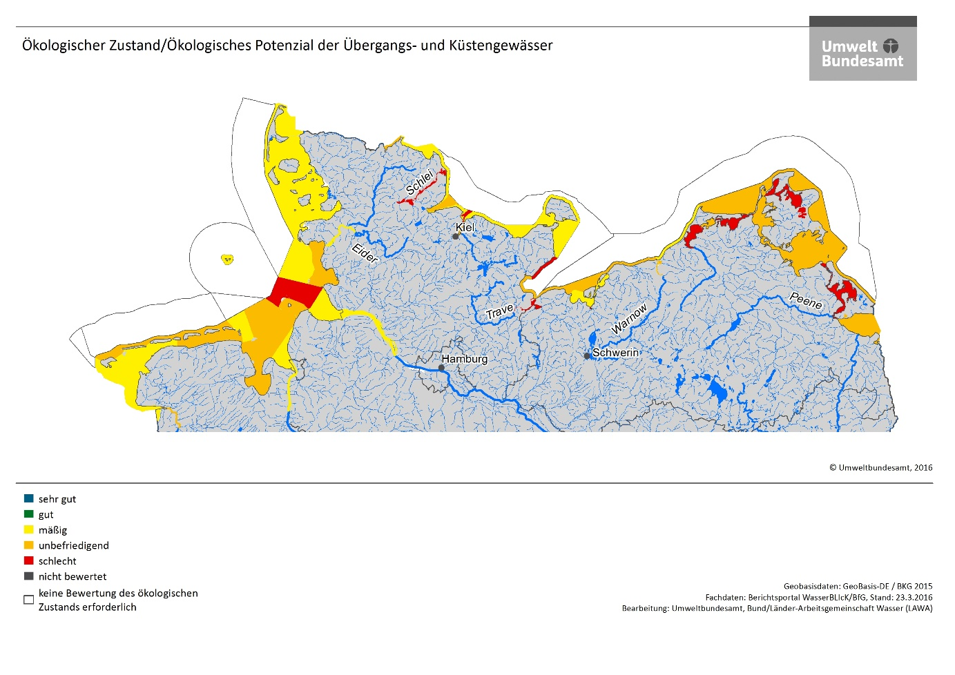
Figure 4 Assessment results according to the Water Framework Directive in coastal and transitional waters of Germany. Source: Umweltbundesamt (www.umweltbundesamt.de).
SOURCE permission
In Germany, the river basin units Eider, Elbe, Ems and Weser are connected to the Wadden Sea area. The most important measures of the management plans for these river basin units with regards to the Wadden Sea fish fauna are measures to ensure the connectivity between sea, estuaries, rivers and streams. Such measures are fishways for up- and downstream migrations e.g. in Geesthacht (Elbe) or Bremen (Weser).
The measures of the WFD eventually may lead to a reduction of nutrient inputs and improve the connectivity between marine and freshwater habitats. In case a further reduction of nutrients is achieved, this should further improve the habitat quality of nursery and spawning habitats in the Wadden Sea. The longitudinal migration of diadromous fish towards spawning and nursery ground in rivers and estuaries might also further improve when fishways are extended or maintained. However, the deepening of the River Elbe and Ems and the resulting degradation of habitat quality may counteract the requirements of diadromous fish species.

Netherlands
The Dutch Wadden Sea has the typology Coastal Water (“Beschut polyhalien kustwater” K2). Whereas the estuaries (type: Transitional water) have fish as a biological quality element that should be evaluated for its species composition and abundance, fish is not evaluated in coastal waters in the WFD. Therefore, Wadden Sea fish are not evaluated in the scope of the Water Framework Directive in the Netherlands.
In the Netherlands, the government translates the WFD into national policy, regulations and tools, based on the Dutch Water Act. The WFD targets are implemented in the “river basin unit management plans “ (Stroomgebiedplannen). The Wadden Sea lies within the river basin unit Rhine for the most part, only the Ems and Dollard lie within the river basin unit Ems (figure 5). However, the Stroomgebiedbeheerplan contains no measures specifically for the Wadden Sea, let alone any measures specifically concerning the fish populations of the Wadden Sea.
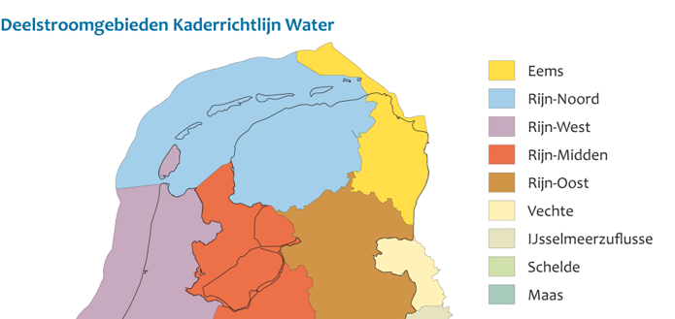
Figure 5 River Basin areas (deelstroomgebieden ) .

Based on the Stroomgebiedbeheerplan Rhine, a number of projects from which the Wadden Sea fish may benefit have been and will be carried out for. These are described in the “Factsheet: NL81_1 Waddenzee” (2015). This factsheet describes the measures carried out until that time, and the intended measures for the period 2015-2021. The measures already carried out are:
RWS_x2433-b - Pilot planting of Seagrass
RWS_x2434-b - Pilot restoration of littoral mussel banks
RWS_x2458a-b – Study on the behaviour of suspended sediment in the Wadden Sea
The measures to be carried out after 2015 are:
RWS_Y2002 – Large scale seeding of Sea grass
RWS-Y9015 - Vispassages Texel Krassekeet en Dijkmanshuizen
RWS_x2458a-c – Research sludge household Waddenzee i.c.m. Deltaprogramma Wadden
RWS_W1020 - Study standard exceeding specific pollutants
The factsheet describes the biological and chemical situation. The biological parameters score as follows:
Macrofauna: average
Water flora: insufficient
Fish: not relevant
The factsheet describes the state of specific pollutants exceeding the standard: Arsenic, Benzo(a)antracene, benzo(a)pyrene, benzo(b)fluoranthene, benzo(ghi)perylene, Mercury, TBT, fluoranthene.
The factsheet states the final assessment of the Wadden Sea as follows:
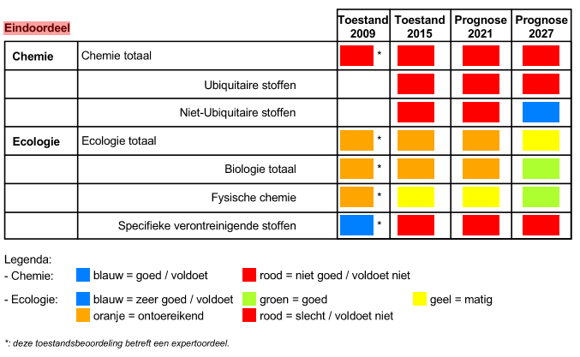
Stroomgebiedbeheerplan Eems 2016-2021
The Ems-Dollard estuary lies within the “stroomgebied” Eems, see the figure below.
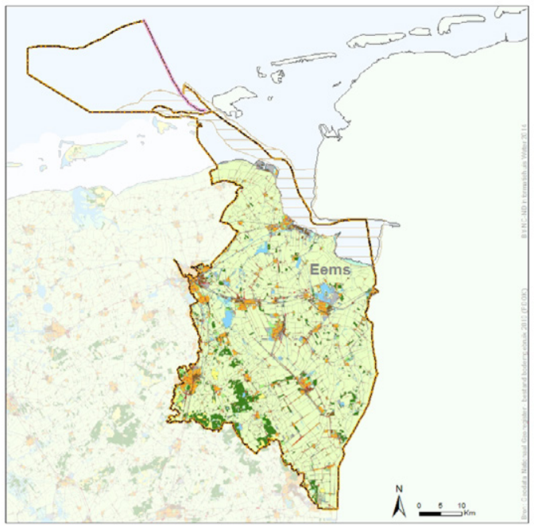

Figure 6 River basin unit Ems

For the river basin unit Eems factsheet: NL81_2 Eems-Dollard (2015) describes the measures carried out until that time, and the intended measures for the period 2015-2021. The measures already carried out are:
Fish passability sluis Nieuw-Statenzijl
Research salt marsh erosion
Research sludge household Eems-Dollard
The measures to be carried out after 2015 are:
Research source specific pollutants
Research sludge household Eems
RWS_W1020 - Study standard exceeding specific pollutants
The factsheet describes the biological and chemical situation. The biological parameters score as follows:
Macrofauna: average
Water flora: average
Fish: average
Fytoplankton: good
The factsheet describes the state of specific pollutants exceeding the standard: Arsenic Benzo(a)antracene, Chryseen, Cobalt, Copper, Silver.

The factsheet states the final assessment of the Wadden Sea in the river basin unit Ems as follows:
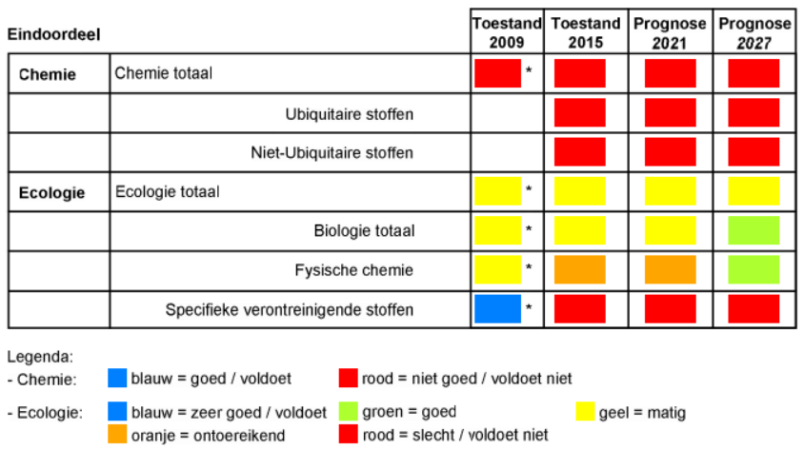

The Dutch WFD measures aim mainly at reducing nutrient and pollutant inputs into the Wadden Sea and removing barriers for diadromous fish. The measures aiming at reducing nutrient end pollutant inputs might improve the water quality, but at this time no part of the Wadden Sea is in a good ecological condition. Most parts of the Dutch Wadden Sea are designated as “Coastal Waters”, without fish as ecological parameters.
A number of WFD measures might benefit fish in due time, if the measures are successful. However, the measures carried out or proposed until this moment are only small scope projects and research projects which may or may not lead to specific measures which will benefit fish. The most relevant measure which may have a positive effect in the long term is the improvement of the water quality, which is an overall goal of the WFD.
Because the river basin unit Rijn has the topology “Coastal Waters”, fish are not part of the biological parameters to be evaluated. That means that for the largest part of the Dutch Wadden Sea the Stroomgebiedsplan does not encompass improvement of fish and fish habitats. For the river basin unit Ems fish are part of the biological parameters, and the current status is “average”. However, the Dutch implementation of the WFD in the Ems estuary contains hardly any measures to enhance the habitat quality and living conditions of fish, except a number of measures to facilitate the migration of diadromous fish species.

General conclusion on the WFD
The first nautical mile from the coast of the Wadden Sea (coastal waters) falls under the regime of the WFD. In 2015, the ecological condition of this Wadden Sea area was assessed as moderate to poor in the three Wadden countries.
Fish are a relevant biological quality component in transitional waters, rivers and streams. In neither of the three countries the KWR contains specific measures for fish for this part of the Wadden area. Nevertheless, the three countries have included measures for the entire river basin, such as improving water quality and connectivity. Both goals may ultimately benefit fish in the Wadden Sea. The significance, pace, and scope of this potential contribution has not been identified in the context of this study.

Marine Strategy Framework Directive

Introduction
The aim of the European Union's ambitious Marine Strategy Framework Directive (MSFD) is to protect the marine environment across Europe more effectively. The Marine Strategy Framework Directive was adopted on 17 June 2008.
The Marine Strategy Framework Directive aims to achieve Good Environmental Status (GES) of the EU's marine waters by 2020 and to protect the resource base upon which marine-related economic and social activities depend. It is the first EU legislative instrument related to the protection of marine biodiversity, as it contains the explicit regulatory objective that "biodiversity is maintained by 2020", as the cornerstone for achieving GES.
In a legislative framework, the MSFD enshrines the ecosystem approach to the management of human activities having an impact on the marine environment, integrating the concepts of environmental protection and sustainable use.
In order to achieve its goal, the MSFD establishes European marine regions and sub-regions on the basis of geographical and environmental criteria: Baltic Sea, North-east Atlantic Ocean, Mediterranean Sea and Black Sea, all located within the geographical boundaries of the existing Regional Sea Conventions (RSC). Cooperation between the Member States of one marine region and with neighbouring countries which share the same marine waters, is already taking place through these Regional Sea Conventions. The Wadden Sea falls into the obligation of the Oslo-Helsinki-Commission (OSPAR).
In order to achieve GES by 2020, each Member State is required to develop a strategy for its marine waters (or Marine Strategy). In addition to this, because the MSFD follows an adaptive management approach, the Marine Strategies must be kept up-to-date and reviewed every 6 years.

Denmark
The MSFD was implemented in Denmark as part of the Danisk Marine Strategy (Danmarks Havstrategi) in 2011. As a result of this, Denmark’s Marine Strategy was published in 2012 comprising three reports: "Initial Analysis", "Environmental Targets" and "Socio-Economic Analysis". The "Initial Analysis" provided an overview of the status of Danish marine areas including which factors are contributing to the situation that not all Danish marine areas have good environmental status. The most important factors were identified as nutrient loads and contaminants dangerous to the environment, as well as fisheries of certain stocks and sea floor impacts due to fishing with bottom towed gear.
The environmental target report identified targets for the environmental status of Danish marine areas, and it described what would be considered a good environmental status. The environmental targets either describe the threshold to be crossed in order to go from 'not good' environmental status to ‘good’ environmental status, or they describe sub-targets to lead progress towards good environmental status. In autumn 2014, a monitoring programme under Denmark's Marine Strategy was published to ensure ongoing assessments of the environmental status in relation to the environmental targets set in the environmental target report for the Marine Strategy. In 2017, this strategy was followed up by a programme of measures. The programme of measures includes specific initiatives on the basis of the environmental targets laid down the environmental target report.
The programme of measures was prepared in the period 2014-2016 by a cross-ministerial cooperation between participants from the Danish Energy Agency, the Danish Maritime Authority, the Danish AgriFish Agency and the Danish Environmental Protection Agency . Furthermore, the Ministry for Defence was regularly informed about the programme.
A significant part of the programme of measures consists of various existing measures under other legislation. The cross-ministerial co-operation reviewed all relevant existing initiatives that have already been launched for the Danish marine environment. Subsequently, a gap analysis has assessed the contribution of the individual measures to achieving the environmental targets, as well as the need for further measures for each environmental target. In situations where the existing initiatives are assessed to be insufficient to reach the environmental targets, new initiatives have been proposed. The cut-off between existing and new measures is 1 January 2015, and new measures are defined as measures adopted after this date.
Furthermore, supplementary initiatives have been included, which, for example through additional knowledge from research or monitoring, will provide the knowledge necessary to enable the launch of initiatives to achieve the environmental targets or which will in other ways support achievement of the environmental targets.

Germany
The Marine Strategy Framework Directive was implemented in Germany as part of the “Wasserhaushaltsgesetz” in 2011. While the MSFD attempts to implement the ecosystem approach to management of marine sectors, in practice it only adds a few new aspects to the conservation and management of marine ecosystems, such as the assessment and management of litter, noise pelagic habitats and function of food webs.
However, new measures are not readily adopted, because the good environmental status of several criteria is not specific enough to allow the formulation of concise management objectives (such as ‘healthy’ age structures in fish populations or proportion of trophic guilds according to prevailing environmental conditions in food webs).
In Germany, measures of the WFD, the BD and HD or the Common Fisheries Policy are included in the marine strategy of member states, while the number of new measures, implicitly implemented through the MSFD, is limited.
The conservation of fish populations and diversity is addressed in Descriptor 1 of the MSFD. Germany lists 32 species as relevant for the MSFD, of which nine species achieve good environmental status (GES), 15 species are not at GES and 8 species could not be assessed due to gaps in data availability (BLANO 2018). The assessment of the population status of these 32 fish species was based on the assessments of the HD, assessments of commercial stocks by the International Council for the Exploration of the Sea (ICES) or the German Red List.
Of the species listed in Table 2, only plaice, eelpout and lump sucker are included within the German MSFD assessment. However, the German MSFD assessment included also two elasmobranchs, thornback ray Raja clavata and spurdog Squalus acanthias, which were based on survey data from the beginning of the 20th century, widely distributed throughout the German Bight including the Wadden Sea (Fock 2014; Fock et al. 2014).
The MSFD did not result in direct measures outside the HD/BD/WFD, but led to an assessment of marine fish species and the impact of benthic disturbances. Also measures to reduce the amount of underwater noise and marine litter may improve the habitat quality of Wadden Sea fish.

Netherlands
The MSFD is implemented in 2010 via the Waterbesluit of the Waterwet (Water Act). The Waterbesluit calls for a National Water Plan (Nationaal waterplan) which describes the measures that should be taken to reach the GES. The Waterbesluit also calls for a Regional Water plan, which should contain a more detailed and specific implementation on the level of the provinces, and a Management plan of national waters on the level of the water bodies managed by the national government. The national and regional water plans and the management plan have a scope which is much broader than the MSFD, with the Water Act including regulation of traffic, etc.
The national government (Rijkswaterstaat) is responsible for the management of the Wadden Sea. The national management plan (Beheerplan Rijkswateren 2016 – 2021) contains amongst others measures for the Wadden Sea. The targets are:
Guaranteeing agreed water safety with coastline care, research and monitoring.
Investing in water quality: implementation of WFD measures and the Natura 2000 management plan.
Guaranteeing the accessibility of the islands for ferries.
Widening the navigation channel from Eemshaven to the North Sea.
The Beheerplan Rijkswateren refers to the WFD and N2000 and does not contain additional relevant policy. It is uncertain if a direct implementation of the MSFD could lead to more effective measures than those already based on the WFD and Habitats Directive.

General conclusion on the MSFD
The MSFD has a somewhat broader objective and requires an ecosystem approach to the management of human activities having an impact on the marine environment, integrating the concepts of environmental protection and sustainable use.
However, for the implementation of this Directive through concrete measures for the Wadden Sea in general and the fishing targets in particular, the three Wadden Sea countries refer to the HD and WFD. Therefore the contribution of the MSFD to the Wadden Sea fish targets could be meaningful, but in reality small.

EU Eel Directive

Introduction
Eel is cited on the IUCN red list as “critically endangered”. Since the early 1980s, a steady and almost continent wide decline of ~90% has been observed in the recruitment of glass eels. While the decline in yellow eel populations was not as severe as that of recruitment, the available data indicated that it was greater than 50% over three generations (45 years). Silver eel decline was not as pronounced as yellow eel populations or recruitment but, similar to yellow eels, the indication was that the decline across the range was greater than 50% over three generations. This may be due to density dependent mortality at previous life stages, but it cannot be ruled out that a decline in silver eel escapement may continue despite increases in glass eels and/or yellow eels due to the long generation time.
The European Eel Directive (EC 1100/2007) aims at restoring the eel populations. It does so by obliging the individual member states to develop and implement national eel management plans including measures to restore the eel populations.

Denmark
In Denmark the Eel Directive is implemented by the Ministry of Food, Agriculture and Fisheries, December 2008 (now called Ministry of Environment and Food Safety). The most recent Danish Eel management plan is from 2008.
In order to ensure that eel recovery measures are effective and equitable, Danish authority identified a series of measures to be taken and areas to be covered with respect to securing the recovering of the European eel stock. Following the adoption of Council Regulation in 2007, Danish fisheries authorities set up an eel management plan task force in order to initiate preparatory work required in connection with the adaptation of and compliance with the Council Regulation. The task force comprised fisheries management experts, legislators and eel scientists from the Technical University of Denmark. The task force will continue its work in the on-going process of monitoring, evaluating and adjusting the measures described in this plan.
The Danish Eel Management plan incorporates the introduction of a framework for effectively managing an extensive reduction in fishing effort, management measures for mitigating structural eel mortality, improving habitat conditions and re-establishing eel stocks. The Plan also includes a number of initiatives, management tools and development projects aimed at strengthening the quality and quantity of eel data. Stakeholder engagement and an open transparent process features the conduction if this plan.

Germany
In Germany the Eel Directive is implemented by the federal states across nine eel management units (EMU). The most recent assessment from 2018 indicates a sufficient overall migration rate of silver eels (> 40% compared to reference conditions) (Brämick and Fladung 2018). However, for the EMUs affiliated with the Wadden Sea (Eider, Elbe, Ems, Weser) the migration rate of silver eels was considerably lower (between 7 to 37% of reference conditions). In the Wadden Sea the predation by harbour seals is considered to be a significant source of natural mortality.
The restoration of eel in Germany focuses on stocking programs as natural recruitment by glass eels is at very low levels (Brämick and Fladung 2018). The implementation of measures to enhance longitudinal connectivity are limited and could be further improved especially in the tributaries of the rivers Elbe, Weser and Ems. The reduction of turbine inflicted mortality on silver eels remains a technical challenge.

The Netherlands
The Dutch Eel Management Plan (Aalbeheerplan) was implemented in 2009, and was evaluated in 2018 (Van de Wolfshaar et al., 2018; CVO Report 18.009).
In the Netherlands, the pristine biomass of silver eel in fresh waters is assessed at 10.400 tons. This implies that 4.160 tons of silver eel should be allowed to migrate annually to the spawning areas, presuming location in the Sargasso Sea. It is estimated that in the years 2014-2016, the Dutch annual escapes were 1.795 tons of silver eel. Therefore, the objectives were not met.
In the evaluation of the Dutch Eel plan (Wolfshaar, 2018), the anthropogenic eel mortality was also analysed. Since 2007, there was a clear reduction in anthropogenic mortality. Up to 2007 it was 81%, with a reduction to 49% in the time period 2014-2016. This was mainly due to the catch reductions in the commercial and recreative fisheries. The mortality of migrating silver eel by barriers (pumps, hydropower stations, sluices) was reduced from 20% to18%, which seems like a small improvement but required high investments by the government and regional authorities (waterschappen).
There has been increasing public awareness for removing fish migration barriers (for upstream migration) but as yet, less attention is paid to the seaward migration of fish (such as silver eel).
Along the Wadden Sea mainland coast, at least 11 sites have been identified which provide barriers for upstream eel migration from the Wadden Sea to inland waters. Several management measures are being implemented in line with EMPs, for example easing of barriers. The influence of these measures, however, will take time to determine as they have only very recently been implemented and very much focus on the freshwater component of the eel's life-history. Arguably the most widely practised measure is restocking; however, there remains a great deal of debate as to whether this benefits eel spawning stocks and thus enhanced future recruitment. Measures that apply to silver eels, such as fisheries management, and/or trap and transport programmes, can theoretically have an almost immediate effect on the potential spawning stock, although when carried out in isolation, their benefit is significantly reduced (IUCN website).
Not only the eel will benefit from the removal of fish migration barriers, also other diadromous species (both anadromous and catadromous) will benefit.

General conclusion on the ED
The Eel Directive will further improve the migration pathways of diadromous fish into tributaries adjacent to the Wadden Sea. Due to the life cycle of eel as catadromous fish, the ED has the potential to improve the connectivity of down-stream migrations.
The eel directive has been implemented in all three countries. The success of the measures differs slightly from country to country, but in general a positive trend is observed.

Common Fisheries Policy

7.1 Introduction
The EU Common Fisheries Policy (CFP) aims to ensure that fishing and aquaculture are environmentally, economically and socially sustainable and that they provide a source of healthy food for EU citizens. Its goal is to foster a dynamic fishing industry and ensure a fair standard of living for fishing communities. Although it is important to maximise catches, there have to be limits. The CFP ensures that fishing practices do not harm the ability of fish populations to reproduce. The current policy stipulates that between 2015 and 2020 catch limits should be sustainable and maintain fish stocks in the long term. To this day, the impact of fishing on the fragile marine environment is not fully understood. For this reason, the CFP adopts a cautious approach which recognises the impact of human activity on all components of the ecosystem. It seeks to make fishing fleets more selective in what they catch, and to phase out the practice of discarding unwanted fish.
The CFP regulates the fisheries in European waters outside the territorial waters (12 nautical mile zone). Important stocks of commercial species, which are also predominant members of the Wadden Sea Fish community, are managed through the CFP. Such species are whiting Merlangius merlangus, plaice Pleuronectes platessa, sprat Sprattus sprattus and herring Clupea harengus. The regulation of fishing activities through catch quotas and spatial measures (see plaice box and Natura2000 sites) will also affect early life stages of these species, which rely on the Wadden Sea as spawning and nursery areas. Hence the sustainable management of commercially exploited fish species supports their abundance in the Wadden Sea area.
Inside the territorial waters i.e. the 12 nm zone, fishing is managed by national jurisdictions of member states. Hence the access of foreign vessels to territorial waters can be limited or restricted.
In 1989 the CFP inaugurated the plaice box, an area in which the fishing with large beam trawls towed by vessels with more than 300 hp engines was prohibited (Beare et al. 2013; Kjaersgaard and Frost 2008) (Figure 6). The impacts of the plaice box on the development of the plaice stocks remained ambiguous, as environmental changes were acting in concordance with the changes in the fishing regime (Beare et al. 2013; Dulvy et al. 2008). Though the plaice stocks did not increase substantially directly after the implementation of the plaice box, it is now at an all-time high.
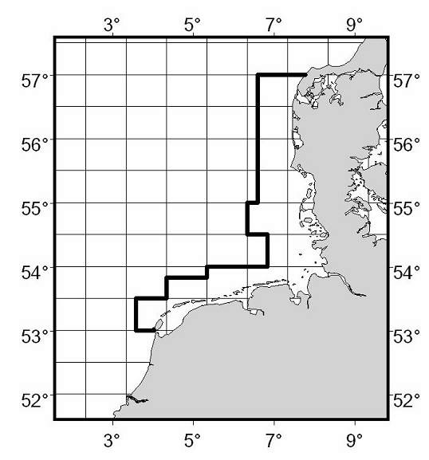
Figure 6 The plaice box, a spatial measure to exclude fishing vessels with more than 221 kW (300 hp) engine power. Source: www.ices.dk.
The most important fishing segment, the beam trawl fisheries for brown shrimp, is not managed under the CFP, as no catch quotas, effort restrictions or spatial measures exist. However, since 2017 the shrimp fisheries Denmark, Germany and the Netherlands have been accredited with the certificate of the Marine Stewardship Council (MSC) (Addison et al. 2017), resulting in a voluntary agreement to use more selective nets to exclude the bycatch of non-target species and small shrimp sizes, to prevent fishing in sensitive habitats, to monitor the shrimp stock size and to adapt the fishing effort in case the stock size declines below critical levels. The shrimp fishers also agreed to accept no-take zones in case scientific recommendations are proposing this measure.

  - Denmark

In Denmark, the common fisheries policy in the Wadden Sea has been implemented in the Statutory order on protection and wild-life sanctuary in The Wadden Sea (Bekendtgørelse om fredning og vildtreservat i Vadehavet), which aims to promote sustainable management of the Wadden Sea. The newest version is from 2007. There has been very little commercial fishing inside the Wadden Sea in the last 25 years, and there hasn’t been given permission for commercial fishing or fishing with machinery since 2007. It is possible in the present version to apply for a dispensation to get license to exploratory fishing – however only one applicant - from the Technical University of Denmark – has been accepted. The Statutory Order is currently under revision. On the outer border of the Wadden Sea (at the border of the protected area) towards the North Sea, shrimp fishing is allowed.
The common fisheries policy is also implemented in general in the national Fisheries Act (Fiskeriloven) which focusses specifically on fisheries and conservation in the Wadden Sea. The act Statutory order on particular regulations for fishery and conservation Zones in The Wadden Sea and certain South Western rivers and streams ( Bekendtgørelse om særlige fiskeriregler og fredningsbælter i Vadehavet og i visse sydjyske vandløb) prohibits fishing with rod and string in the streams that are connected to the Wadden Sea in parts of the year. Furthermore, an area of 500 m from several creeks and streams are protected. It also puts restrictions on what types of fishing gears are allowed in the Wadden Sea. Restrictions on fisheries is very relevant for the state of the fish in the Wadden Sea.
Further there is another statutory order connected to the general Fisheries Act specifically concerning the fishery of blue mussels in the WS concerning the formal regulations in connection with licensing.

Germany
Since 1992 dredging of cockles is prohibited (only manual collection is allowed in some parts). The fisheries and cultivation of blue mussels is restricted to licensed operators which have to follow a co-operative management plan between the license holders and the government of Niedersachsen (see section on Habitats Directive). Shrimp fishing is allowed in all three parts of the national park apart from a small no-take zone between the islands of Sylt and Föhr. However, there have been issues with enforcing this no-take zone and violations have been reported.
  - The Netherlands
In the Netherlands, the common fisheries policy has been implemented in the Fish Law (Visserijwet 1963) with a follow-up in the Sea and Coast Fisheries Act (Reglement zee- en kustvisserij 1977, valid from 01-01-2015 up to date) and translated into a regulation on Fish (Uitvoeringsregeling Visserij). Fish species can be included in the Fisheries Act with a minimum size and / or closed seasons.
Fishery in the Wadden Sea is categorised as Coastal fishery. There are specific agreements, such as VIBEG (in North Sea coastal zone), VISWAD, mosselconvenant. In the VIBEG agreement, some parts of the coastal zone of the North Sea are closed to all or specific forms of fisheries.
The change of mussel seed fishery to the use of MZI’s and the changes in shrimp fishery (more sustainable way of fishing) may have a positive impact on the habitat of the fish (long term) and the amount of bycatch of fish (short term).

VISWAD aims at the transition to a more sustainable way of shrimp fishing, the accreditation with the certificate of the Marine Stewardship Council (MSC) is one of the results of the more sustainable way of fishing.
The Mosselconvenant is an agreement on the transition of mussel seed fishery to spat collectors. At this moment this has led to a reduction of about 50% of the mussel seed fishery. This has led to a substantive reduction of the disturbance of the sea bed by this form of fishery. At this moment negotiations are conducted on a further transition to spat collectors.

General conclusion on the CFP
The CFP is mainly used to regulate fisheries, to ensure that the commercial fish population is maintained at a certain reproductive level to “produce” enough fish. Measures regarding fishing methods, reduction bycatch an reducing environmental impacts may also support the (ecological) fish targets. The CFP has the potential to further improve and maintain the stock status of commercially exploited fish species such as plaice, sole, whiting and herring. The CFP is not aimed at contributing to the conservation of spawning or nursery habitats nor the improvement of migration pathways.
The implementation of the CFP clearly differs per country. Germany has established a permit system for specific species and designated areas. Whereas the Netherlands has made agreements with the various professional groups via supplementary covenants and regulates fishing inside Natura 2000-sites in permits on the Nature Conservation Act, Denmark has since 2007 designated areas closed for fisheries. In the last 12 years there has only being given 1 dispensation to do exploratory fishing. A revision of the “Statutory order on protection and wild-life sanctuary in The Wadden Sea” is reviewing (among others) the future of the present possibilities to dispensate of the general prohibition for shellfish fishery.

Ballast Water Management Convention

Introduction
The International Convention for the Control and Management of Ships' Ballast Water and Sediments (BWM Convention, which came into force on September 8th, 2017) requires ships to manage their ballast water to remove, render harmless, or avoid the uptake or discharge of aquatic organisms and pathogens within ballast water and sediments. One example of such invasive species in the Wadden Sea is the comb jelly (Mnemiopsis leidyi), which travelled in ship’s ballast water. Examples of fish species that are mentioned on the website of imo.org are: round goby Neogobius melanostomus. Furthermore, there is record of Atlantic croaker.
The Ballast Water Management Convention aims to prevent new introduction of invasive alien species via ballast water. It will not prevent further growth of populations of alien species already present.

Denmark
The implementation of the BWMC is under the responsibility of the Danish Maritime Authority (Søfartsstyrelsen). The purpose of the ballast water management convention is to prevent the introduction of invasive species from ships’ ballast water.
The concept of “Same Risk Area”, developed in Denmark, has now been approved by the IMO, and it has been decided that it can be used already now. This means that, rather than making a risk assessment per ship route, you can make a risk assessment for minor sea areas (following an agreement the authorities of all the countries affected); this would be considerably easier to handle for both shipowners and the authorities.
The implementation of BWMC in DK has led to the fist e-DNA program being introduced on an operational basis in the country

Germany
The implementation of the BWMC is under the responsibility of the Federal Maritime and Hydrographic Agency (Bundesamt für Seeschiffahrt und Hydrographie, BSH). This agency has a strong focus on technical applications and hence is responsible for the approval of ballast water treatment systems of vessels, which intend to reduce the amount if viable organisms in discharged ballast water. The BSH has licensed several ballast water management systems so far. By 2024, all vessels have to fulfil the quality criteria of ballast water management.
A national monitoring initiative (rapid assessment survey, RAS) of non-native species is conducted along eleven sampling sites in harbours and marinas along the German North Sea coast. This monitoring program covers sampling of pontoons, harbour walls and rocky substrates. As a result of a joint harmonized procedure between HELCOM and OSPAR to fulfil the monitoring obligations of the Ballast Water Management Convention, the German RAS programme has been extended by monitoring of settlement panels (eRAS).
So far, 101 non-native species have been recorded in the German North Sea, of which the round goby Neogobius melanostomus has been recorded as the only established invasive fish species. The round goby is a highly adaptable and invasive fish species. Increases in numbers and spreads quickly. It competes for food and habitat with native fishes including commercially important species, and preys on their eggs and young. It spawns multiple times per season and survives in poor water quality.
In the Wadden Sea, the invasive non-vertebrate species with the most severe impact was the pacific Oyster Crassostrea gigas, which. The ecological consequences of the introduction of the Pacific oyster are not considered as negative, as this oyster species provides habitats for a new sessile community of Japanese wireweed Sargassum muticum, blue mussels and other sessile invertebrates and thereby increases ecosystem diversity and complexity (Buschbaum et al. 2012).
With regard to non-native invasive species the German legislation is focussing on reducing the introduction of new species, either from ballast water or biofouling. Within the MSFD an introduction rate of less than three species per six years is considered as compliant to a good environmental status. Eradication measures of non-native invasive species have not been conducted so far, as they are considered to be non-effective and disruptive to newly established diverse communities (Buschbaum et al. 2012).

Netherlands
The Ballast Water Management Convention is implemented in the Dutch Act on the prevention of pollution by ships (Wet voorkoming verontreiniging door schepen). This law does not only regulate the use of ballast water, but also a.o. the use of anti-fouling. It contains a complete implementation of the BWMC with no additional regulation concerning ballast water. The Dutch Human Environment and Transport Inspectorate)of the Ministry of Infrastructure and Water Management is responsible for enforcing this law in the Netherlands.
The round goby was recorded in the NIOZ fyke monitoring in the western Dutch Wadden Sea in 2015 and may have been transported by ballast water or it may have migrated via the Danube-Rhine canal. The round goby has already established its stomping grounds in the south of the Netherlands and in Lake IJssel. It is a freshwater goby, which can also live in brackish waters, so it could have been expected that it would one day also appear in the Wadden Sea. However, researchers didn’t come across it until 2019. It can therefore be surmised that since 2015, an extra fish species is present in the Wadden Sea.
The Atlantic croaker or ‘knorrepos’ in Dutch (Micropogonias undulatus), was recorded in 2003 in the Wadden Sea, but there are no further reports.

General conclusion on the BWM Convention
The BWMC is implemented in the three countries. This leads to measures that may delay or prevent the introduction of alien species in the Wadden area. It is difficult to predict the influences of the Ballast Water Management Convention and other prevention measures on the fish fauna of the Wadden Sea. The introduction of a single non-native species can alter the structure and function of an entire ecosystem within short time frames. But the implementation of the Ballast Water Management Convention along with local measures to reduce the introduction of non-native species presumably reduces the risk of catastrophic invasions.

Other regulations and agreements

Alien Species Regulation
Regulation (EU) 1143/2014 on invasive alien species (the IAS Regulation) entered into force on 1 January 2015, fulfilling Action 16 of Target 5 of the EU 2020 Biodiversity Strategy. The core of the IAS Regulation is the list of Invasive Alien Species of Union concern.
This issue has been prioritized in the Leeuwarden Declaration 2018, and a strategy to that effect is under implementation. A comprehensive list of Alien Species in the Wadden Sea Area have been developed and is maintained on a regular basis.

Maritime Spatial Planning Directive
The Maritime Spatial Planning Directive to marine waters of Member States, does not apply to coastal waters or parts thereof. The relevance for this policy analysis is low.

CITES
Convention on International Trade in Endangered Species of Wild Fauna and Flora (CITES). The list of protected species in CITES comprises some shark and ray species, sturgeons (a.o. Atlantic sturgeon Acipenser sturio), eel (Anguilla anguilla), Syngnathid fishes (a.o. Syngnathus acus, S.rostellatus, Hippocampus spp.). None of these species occur in the Wadden Sea, which means this convention is not relevant for this study.

Conclusion and next steps

Conclusion regulation fish species

Of the directives, conventions and legislation described, only the Habitats Directive contain specific and concrete measures for habitats and a small group of fish species in the Wadden Sea. The N2000 measures focus mainly on the qualifying habitats and seem to overlook the importance of measures aimed at the species which use these habitats and the importance of fish as a crucial part of the Wadden Sea ecosystem nans food chain.
Fish species may benefit from the measures aimed at preserving and restoring habitats, but the effect thereof is difficult to estimate and is hardly monitored. It can be observed, however, that the designation of N2000 areas provides the possibility to limit or even exclude certain (potential) threatening human activities. The three countries deal with this differently.
The WFD applies to the coastal zone. Here too, targets for specific fish species are often lacking, but much attention is paid to water quality and the removal of barriers, particularly for diadromous fish. With this, the WFD can indeed contribute to the fishing targets, but in the context of this study it is difficult to say to what extent and at what speed this actually happens.
The Eel directive has a clear and specific purpose. The measures aimed at removing physical barriers will also help other migrating fish species.
The Marine Strategy Framework Directive, the Alien Species Regulation, the Ballast Water Management Convention and the Common Fisheries Politics are relevant for this policy review, but contribute only in an indirect way or in the long term to improvement of fish species. The other reviewed policy and legislation are not relevant for fish species in the Wadden Sea.

Conclusion regulation and trilateral fish targets

Where in the previous chapters the focus has been on fish, the question is also to what extent the trilateral fishing targets are supported by European legislation. A short conclusion per targets follows hereafter.
- Viable stocks of populations and a natural reproduction of typical Wadden Sea fish species.
The definition of typical Wadden Sea fish has not been found in any of the described regulations, nor policies to enhance viable stock of Wadden Sea fish species. For commercial fish, the CFP provides the basis for measures regarding viable stocks. These may also include species that are classified as typical Wadden Sea species, but the purpose of this scheme is fishing and not protection.
2. Occurrence and abundance of fish species according to the natural dynamics in (a)biotic conditions.
Measures to conserve or restore natural dynamics in (a) biotic conditions derive from restricting or even excluding human activities. Only Denmark prohibited human activities in the designated Natura2000 sites. The Dutch implementation aims at restricting some human activities.
The MSFD might be used to improve the natural dynamics in (a) biotic conditions, but neither of the three countries do more than the HB and WFD require.
3. Favourable living conditions for endangered fish species.
The (short) list of fish species in Annex IV HD probably does not cover all endangered Wadden sea fish species. Measures based on the HD and WFD regarding habitats will contribute to favourable living conditions for fish, such as of adequate levels of food supply, unpolluted water and negative impacts of human activities. The focus of these measures however is not aimed at endangered fish species.
4. Maintenance of the diversity of natural habitats to provide substratum for spawning and nursery functions for juvenile fish.
Measures to restore, conserve and maintain the diversity of natural habitats, such as sea grass, oyster- and blue mussel banks are part of the N2000 management plans. Additionally the MSFD provides a basis for a more integrated approach, but this possibility has not been used up to now.
5. Maintaining and restoring the possibilities for the passage of migrating fish between the Wadden Sea and inland waters.
Both the WFD and the Eel Directive contain measures to mitigate barriers between the inland fresh water systems and the Wadden Sea.

Next steps
The link between the fish targets and regulations is weak. Both the regulations and the fish targets are formulated at a generic and abstract level. This is partly due to lack of knowledge, as mentioned in the Swimway Action Programme (2019), which concludes “The main benefit arising from the swimway research will be the identification of population bottlenecks and the translation of this knowledge into effective management and conservation measures. Closing these knowledge gaps will help to improve effective conservation.”
The known demands of the fish species and the known threats are quite generic. As a result, it is difficult to determine which specific measures will benefit fish populations. It is therefore not surprising that current regulations, as reviewed in this study, provide a far from complete conservation framework.
Fish ecosystem requirements are known to a limited extent. This calls for research specifically aimed at pinpointing the bottlenecks for the achievement of the Fish Targets. Assuming a lot of knowledge is already available, the research could start with a meeting of a number of experts with a lot of insight in the research already conducted.

It therefore seems necessary to conduct targeted research into the underlying causes of the decline in fish populations in the Wadden Sea. If the causes of this decline are better known, targeted policies can be developed to resolve these bottlenecks. Now that these bottlenecks are not or insufficiently known, it is difficult to assess to what extent the existing policy is effective. This makes it difficult to encourage policy makers to develop specific fish policy. Current policy can be an effective instrument in realising the fish targets, but we have to find
Based on this, the following next steps are proposed.
- Formulate specific definition of Wadden Sea typical fish species and communities
- Assess (Potential) endangered species and causes of decline (abundance, species composition, etc)
- Investigate impacts of major threats and dominant causal relations. It could be useful to aim the research at ecological groups of fish species (ecological guilds) with a more or less similar behaviour and ecological demands.
- Define Smart restoration and conservation targets
- Lobby for a proper and specific fish conservation policy. If the need arises to adapt measures based on the Habitats Directive, the most logical way is to implement these measures in the Natura 2000 and WFD plans. These plans are rewritten once every six years. The next revision is foreseen in 2021. Lobby by the trilateral partners at the European level, but also at the national level is needed to enhance the attention for the Wadden Sea Fish populations

Citations
Addison, J., Gaudian, G., Knapman, P., 2017. MSC sustainable fisheries certification, In Publilc Certification Report. p. 428. Acoura.
Anonymous, 2017. Kurzbewertung des Bewirtschaftungsplans Miesmuschelfischerei im Nationalpark "Niedersächsisches Wattenmweer", p. 38. COFAD GmbH, Weilheim.
Beare, D., Rijnsdorp, A.D., Blaesberg, M., Damm, U., Egekvist, J., Fock, H., Kloppmann, M., Röckmann, C., Schroeder, A., Schulze, T., Tulp, I., Ulrich, C., van Hal, R., van Kooten, T., Verweij, M., 2013. Evaluating the effect of fishery closures: Lessons learnt from the Plaice Box. Journal of Sea Research 84, 49-60.
BLANO, 2018. Zustand der deutschen Nordseegewässer 2018, In Umsetzung der Meeresstrategie-Rahmenrichtlinie. p. 191. Umweltbundesamt, Bonn.
Brämick, U., Fladung, E., 2018. Umsetzungsbericht 2018 zu den Aalbewirtschaftungsplänen der deutscheln Länder 2008, p. 62. Institut für Binnenfischerei e.V. , Potsdam-Sacrow.
Buschbaum, C., Lackschewitz, D., Reise, K., 2012. Nonnative macrobenthos in the Wadden Sea ecosystem. Ocean & Coastal Management 68, 89-101.
Davenport, J., 1985. Synopsis of biological data on the lumpsucker Cyclopterus lumpus (Linnaeus, 1758). FAO fisheries synopsis no. 47.
Dulvy, N.K., Rogers, S.I., Jennings, S., Stelzenmüller, V., Dye, S.R., Skjoldal, H.R., 2008. Climate change and deepening of the North Sea fish assemblage: a biotic indicator of warming seas. Journal of Applied Ecology 45, 1029-1039.
Fock, H.O., 2014. Patterns of extirpation. I. Changes in habitat use by thornback rays Raja clavata in the German Bight for 1902-1908, 1930-1932, and 1991-2009. Endangered Species Research 25, 197-207.
Fock, H.O., Probst, W.N., Schaber, M., 2014. Patterns of extirpation. II. The role of connectivity in the decline and recovery of elasmobranch populations in the German Bight as inferred from survey data. Endangered Species Research 25, 209-223.
I&M 2016 Natura 2000-beheerplan Waddenzee 2016-2022. Ministerie van Infrastructuur en Milieu, Rijkswaterstaat Noord Nederland. Juni 2016.
Kjaersgaard, J., Frost, H., 2008. Effort allocation and marine protected areas: is the North Sea Plaice Box a management compromise? ICES Journal of Marine Science 65, 1203-1215.
Naturstyrelsen, Miljøministeriet, 2013. Natura 2000-basisanalyse 2015-2021 for Vadehavet - Vadehavet med Ribe Å, Tved Å og Varde Å, H86 Brede Å, H90 Vidå med tilløb, Rudbøl Sø og Magisterkogen og F57 Vadehavet, Natura 2000- område nr. 89, Habitatområde H78, H86 og H90, Fuglebeskyttelsesområde F57.
Naturstyrelsen, 2011. Vandplan 2010-2015, Vadehavet, Hovedvandopland 1.10 Vanddistrikt: Jylland og Fyn.
Miljøstyrelsen, N.D. MiljøGIS for Vandområdeplanerne 2015-2021. http://miljoegis.mim.dk/spatialmap? profile=vandrammedirektiv2-bek-2019
Søgaard, B., Skov, F., Ejrnæs, R., Pihl, S., Fredshavn, J., Nielsen, K.E., Clausen, P., Laursen, K., Bregnballe, T., Madsen, J, Baatrup-Pedersen, A., Søndergaard, M., Lauridsen, T.L., Aude, E., Nygaard, B., Møller, P.F., Riis-Nielsen, T., & Buttenschøn, R.M., 2007. Criteria for favourable conservation status in Denmark. Natural habitat types and species covered by the EEC Habitats Directive and birds covered by the EEC Birds Directive. National Environmental Research Institute, University of Aarhus. 92 pp. – NERI Technical report No. 647. http://www.dmu.dk/Pub/FR647.pdf
Polte, P. & H. Asmus (2006). Intertidal sea grass beds (Zostera noltii) as spawning grounds for transient fishes in the Wadden Sea. Mar. Ecol. Prog. Ser. 312: 235-243.
Ulleweit, J., Stransky, C., Panten, K., 2010. Discards and discarding practices in German fisheries in the north Sea and Northeast Atlantic during 2002-2008. Journal of Applied Ichthyology 26, 54-66.

Colophon

Title: | Policy review Swimway Wadden Sea, Review of international and national policies and legislations
Author(s): | B.J.H. Koolstra MSc & Dr. Z. Jager PM, Buitenkamp M other authors
Commissioner: | Programma Rijke Waddenzee
Report number: | 2019-017-03
Version: | 0.5
Date: | February 2020
Status: | Draft
Citation: | Koolstra, B.J.H, Z. Jager, M Buitenkamp, other authors 2020. Policy review Swimway Wadden Sea, Review of international and national policies and legislations. Report number 2019-017-03. Koolstra-Consultancy, Assen.
© Reproduction of parts of this report or re-use of data from this report is permitted with acknowledgment of the source

Action programme Swimway Wadden Sea, 2019, CWSS
Leeuwarden Declaration 2018, WSB
Action programme Swimway Wadden Sea, 2019, CWSS
The Natura 2000-network comprises both the SAC and SPA areas.
N2000 >Plan 2016-2021 “N89 - Wadden Sea”: https://mst.dk/media/130303/n89_f53_n2000plan_2016-21.pdf,
Synonym: Japanese oyster, Miyagi oyster
"Directive 2000/60/EC of the European Parliament and of the Council establishing a framework for the Community action in the field of water policy
See http://publicaties.minienm.nl/download-bijlage/99755/printversie-bprw-2016-2021-zonder-links-tcm21-72095.pdf from page 174 onwards.
https://www.iucnredlist.org/species/60344/45833138#population.
https://ec.europa.eu/fisheries/cfp_en
www.msc.org/de/aktuelles/zertifizierung-nordseekrabben
Probst, oral communication.
http://www.imo.org/en/MediaCentre/PressBriefings/Pages/21-BWM-EIF.aspx
www.neobiota-plattform.de/listen/.
www.imo.org
https://www.nioz.nl/en/expertise/wadden-delta-centre/news-media/fyke-stories/catch-of-a-round-goby
www.nioz.nl
http://ec.europa.eu/environment/nature/invasivealien/index_en.htm
https://www.eea.europa.eu/policy-documents/directive-2014-89-eu-maritime
http://ec.europa.eu/environment/cites/legislation_en.htm

