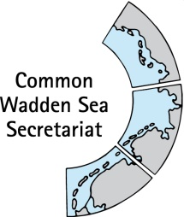
MEETING DOCUMENT
Task Group Management (TG-M 21-1)
28 January 2021
Online meeting

Agenda Item: 5. Shipping
Subject: Round table shipping
Document No.: TG-M 21-1/5/2
Date: 18 January 2021
Submitted by: Wadden Sea Forum

This document contains an update on recent developments on planning of a round table shipping by the Wadden Sea Forum

Proposal: The group is invited to note the document

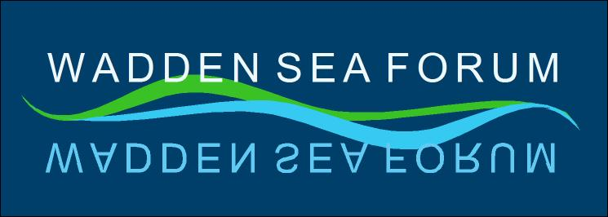
WSF Round Table
Shipping

Process
General Date: 28 January 2021

What? | Detail/Item | Who?
Process, Structure  and Content | - Organisation & Communication  - Stakeholder analysis  - Structure and Content of RT  - Invitation | WSF  (supported by TG-M & CWSS)

Schedule

Item | What? | Who? | Estimated completion
Identification of potential attendees | Identification of  - German participants  - In consultation with  - Thomas Borchers and Gregor Scheiffarth  - WST  - Dutch participants  - In consultation with  - Floris van Bentum  - Karst Jaarsma  - Danish participants  - In consultation with Henrik Pind Jørgensen | WSF | Done
Communication | Calling selected participants and conducting a survey asking for  - Stake, motivation and aims  - Further stakeholders | WSF | Done
In-depth interviews | Potential participants at the first Round Table “Shipping” | WSF | Starting Mid-February 2021
Meeting date (online) | Spring 2021  - April – week 16: 19. – 23.4.  - April – week 17: 26. – 30.4. | All | Mid-February 2021
Official Invitation | - First draft  - Review  - Final draft and sending | WSF, CWSS, TG-M | Mid-February 2021

Round Table ”Shipping”
It would be important to involve a broad spectrum of actors in the discussion with the aim to improve topics around ”shipping” in the southern North Sea. Therefore, it is proposed to establish a Round Table (RT) ”Shipping” with representatives of shipping authorities, ports, green NGOs, stakeholders and representatives of the society (municipalities, counties/provinces) to advise the Wadden Sea Board. This group should be independent and without formal/ hierarchical regulations – the function is more on an advisory level, which may enable a better collaboration among authorities and stakeholders. This group will be facilitated by the WSF secretariat with the support of the CWSS/TG-M.
Tasks
The overall task of the Round Table ”Shipping” is to exchange information and experiences about, e.g. the safety practices and to elaborate on advices how shipping safety and related topics in the southern North Sea can be improved, considering the vulnerability of the World Heritage Site Wadden Sea. The evaluation of 2017 on the operational plans as part of the Tønder Declaration together with the outcomes of the report on ”Shipping and ports in the Wadden Sea World Heritage” can be used as a starting point. Ideas of contents in this Round Table could be:

- Get acquainted to each other
- Get updated
  - on the recent developments in the participating states concerning shipping
  - on the status of the World Heritage Site Wadden Sea (i.e. SIMP)
  - on the recent developments in the Wadden Sea society (i.e. informing about the statements of the advisory boards, positions of the NGO’s, ...)
- Setting the scene on relationship between Shipping and World Heritage
  - Identifying threats, probelms and challenges
  - Prioritise identified topics
- Discussion and strving for consensus about further process. Further elaboration of specific tasks could be done in separate working groups.
Reporting
The RT “Shipping” will report regularly about developments and progress to the TG-M and WSB.

Round Table ”Shipping”
Spring 2021 - online

Draft Agenda
1. Opening
The chair, Ms. Janne Liburd, will open the Round Table ”Shipping” at 10:00 hours.
An introduction about the background and the aim of the meeting will be given. Participants are invited to adopt the draft agenda.
2. Round of introduction
A round of introduction will take place to get acquainted with each other.
3. Introductory presentations
In the first part of the Round Table meeting some presentations will be given to provide information, valuable for the objectives of the Round Table and to be taken into account.

- The Wadden Sea World Heritage Site and resulting responsibilities of the society
Bernard Baerens or Dr. Soledad Luna, CWSS
- Key messages of the report on ”Shipping and ports in the Wadden Sea World Heritage”, Christian Bahlke, AINS
- Overview about how shipping businesses and issues are organized in the three Wadden Sea countries:
  - Organisation of shipping issues in the Netherlands, ??, Ministry of Transport and Environment
  - Organisation of shipping issues in Denmark, ??, Danish Maritime Authority
  - Organisation of shipping issues in Germany, ??, Ministry of Transport and Digital Infrastructre
- Update of the MS Zoe accident and lessons learnt
NL inspection council, Onderzoeksraad voor Veiligheid
4. Exchange of views
The participants are invited to contribute to an exchange of views how to meet the concerns of the society along the coast as well as views on possible measures to increase shipping.
5. Future steps
The meeting is invited to agree on further steps and actions to reach common sense about possible measures for a safe and sustainable shipping business in the southern North Sea.
6. Closure
The round table will be closed around 15:00 at the latest.

Potential Participants

No. | Status | Institution | Country
1 | Government | Danish Naval Command | DK
2 | Government | Ministry of Environment and Food of Denmark | DK
3 | Government | Danish Maritime Authority | DK
4 | Government | DanPilots | DK
5 | Government | Dutch Coast Guard | NL
6 | Government | Ministry for Infrastructure and Water Management | NL
7 | Government | Rijkswaterstaat Noord-Nederland | NL
8 | Government | Havariekommando | D
9 | Government | Bundesministerium für Verkehr und Digitale Infrastruktur (BMVI) | D
10 | Government | Bundesministerium für Umwelt, Naturschutz und nukleare Sicherheit (BMU) | D
11 | Government | Niedersächsisches Ministerium für Umwelt, Energie, Bauen und Klimaschutz (MU) | D
12 | Government | Ministerium für Energiewende, Landwirtschaft, Umwelt, Natur und Digitalisierung (MELUND) | D
13 | Government | Wasserstraßen- und Schifffahrtsverwaltung (WSV) | D
14 | Association | Bundesverband der See- und Hafenlotsen | D
15 | Municipalities/NP | Omgevingsberaad Waddengebied | NL
16 | Municipalities/NP | Niedersachsen | D
17 | Municipalities/NP | Schleswig-Holstein | D
18 | Advisory | Counseling Danish WS | DK
19 | Shipowner | KVNR | NL
20 | Shipowner | VDR | D
21 | Shipowner | Danish Shipping | DK
22 | NGO’s | Wadden Sea Team | Trilateral
23 | Ports | Cooperation of Wadden Sea Harbours | Trilateral?
24 |  | Janne Liburd (chair) | Trilateral
25 |  | Frank Ahlhorn (secretary) | Trilateral

