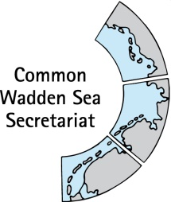
MEETING DOCUMENT
Task Group Management (TG-M 20-1)
17 - 18 April 2020
Bremen, Germany

Agenda Item: 8. Energy
Subject: Renewable energy, Energy from Oil and Gas, Coastal flood defense and protection
Document No.: TG-M 20-1/8
Date: 5 March 20
Submitted by: CWSS
At the Wadden Sea Board (WSB) meeting 30 held on 21 November 2019 in Wilhelmshaven, Germany, the Board endorsed the four key topics for the SIMP: fisheries, tourism, shipping and impacts from outside (specifically renewable energy, energy from oil and gas and coastal flood defence and protection).
In the Joint SIMP meeting on 23 January 2020 in Hamburg, TG-M and TG-WH discussed and agreed on a referential structure for each key topic and on the next steps to develop the content. The identified next steps are to draft the content of the heading “Inventory” focusing on the legal framework to revise and improve, and to TG-M to propose working approach.
This document contains a draft of two headings of the agreed referential content structure for renewable energy, energy from oil and gas: “Inventory” and “Common ground” as a first draft content to discuss upon, revise and improve.

Proposal: The group is invited to revise and comment the draft.
The group is invited to discuss and propose a working approach.

Overview of the current situation of energy exploitation adjacent to the Wadden Sea World Heritage

Background
WSWH Managers and TG-WH identified “Impacts from outside” as a key topic for the SIMP, also endorsed by the WSB 30. The joint SIMP meeting (TG-M and TG-WH) agreed to specify the title of this key topic from “Impacts from outside” to “Renewable energy”, “Energy from Oil and Gas” and “Coastal flood defence and protection”. The meeting also agreed on a referential content structure (Annex 1).
The following draft text addresses “Renewable energy” and “Energy from Oil and Gas” separately. It gives a brief definition of what are we referring to with Renewable energy” and “Energy from Oil and Gas” in the Wadden Sea, what is the current status, the common agreements, trends and threats. The sources of information used were the WSP 2010, the QSR 2017, the Nomination Dossiers from 2008 and 2014, and ec.europa.eu/energy.
This draft is a basis for further reflection on the level of detail needed and wanted in the content of the headings “Inventory” and “Common ground”, as well as for identifying whether there is the need to update certain information and if there is additional relevant information that needs to be considered.

Renewable energy - draft
Renewable energy in the Wadden Sea refers to wind energy and the associated laying of high voltage transfer cables.
Inventory
There are no wind farms or wind turbines within the Wadden Sea World Heritage property. The transfer cables cross underneath the property. Figure 1 shows the Wind farms in the Netherlands, Germany and Denmark and the cable corridors.
A detailed inventory per country can be developed and included in an online version.
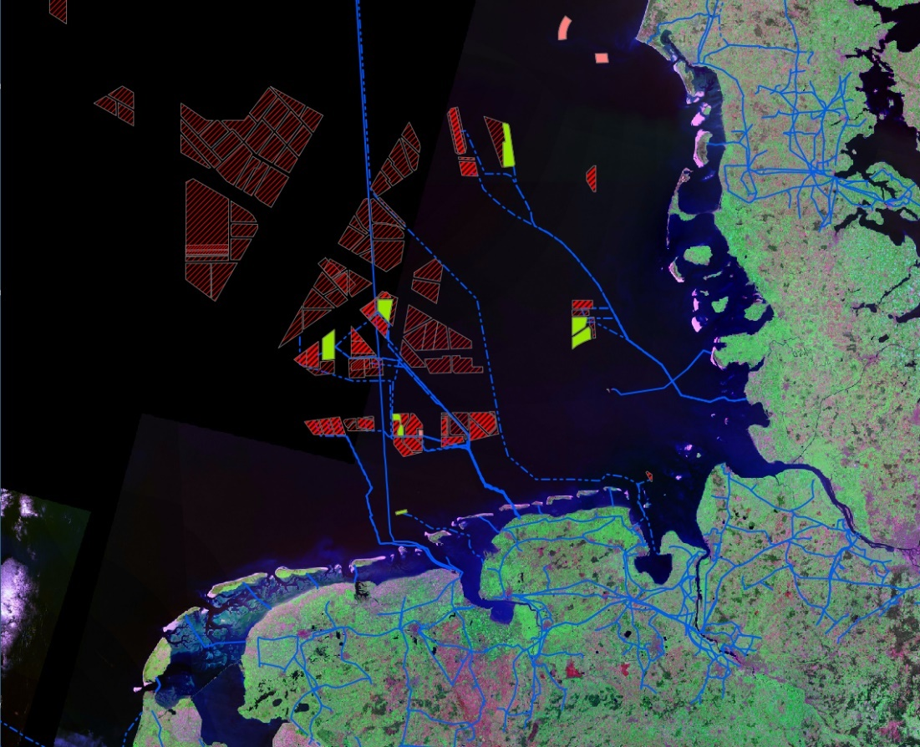
Figure 1. Wind farms (operating and planned) in the Netherlands, Germany and Denmark and high voltage cables in blue. LEGEND NEEDS TO BE INCLUDED.

Common ground
The Wadden Sea Plan 2010 states the trilateral agreements:
- The construction of wind turbines in the Nature Conservation Area is prohibited (the Wadden Sea World Heritage property).
- The construction of wind turbines, in the Wadden Sea Area outside the Nature Conservation Area (WSWH) is only allowed, if important ecological and landscape values are not negatively affected (WSP, 2010).
- To concentrate cable crossings through the Wadden Sea within a minimum of cable corridors and a minimum of cables using the best available techniques, e.g. cables with highest capacity available, and to communicate regularly on this item in order to use synergies.

These agreements are backed up by law in the three countries (Table 1). Nonetheless, the associated cable laying and connections to the mainland occur through the WSWH property.

Table 1. A. Legal framework that prohibits the development of windfarms in the Netherlands, Denmark and the three German Federal States. B. National policies that support the energy transition to renewable sources. C. Relevant enterprises running windfarms adjacent to the WSWH/laying cables underneath the WSWH. Source QSR: Energy, 2017; Nomination Dossier, 2012.
 | Legal framework to prohibit development of windfarms within the WS | Policy to promote renewable energy | International legal framework to regulate construction
Wadden Sea World Heritage property in…
…the Netherlands | Dutch Conservation Area (PKB Area) | Energy Agreement for Sustainable Growth  National Energy and Climate Plan (NECP)* | Habitats Directive ++
Germany |  | Renewable Energy Sources Act (RES-Act) | Habitats Directive ++
Lower Saxony | National Park Act
Hamburg | National Park Act
Schleswig-Holstein | National Park Act
Denmark | Danish Statutory Order | Energy Act  National Energy and Climate Plan (NECP)* | Habitats Directive ++
* To meet the EU’s energy and climate targets for 2030, EU Member States need to establish a 10-year integrated national energy and climate plan (NECP) for the period from 2021 to 2030. Introduced under the Regulation on the governance of the energy union and climate action (EU/2018/1999), the rules requires the final NECP to be submitted to the Commission by the end of 2019 (ec.europa.eu/energy).
++ Habitat Directive for assessment and permission for construction of corridors for laying power cables across the area.

Trends
Wind energy generation has a very important role in Europe. From a total of 3,018.5 MW provided in European waters, 86.1 % were in the North Sea, 9.2 % in the Baltic Sea, and 4.7 % in the Irish Sea (data from 2015 in QSR, 2017). The governments from the Netherlands, Germany and Denmark have plans to increase the generation of renewable energies to progressively lower fossil fuel use. Figure 1 shows the planned increase in Megawatts production between 2020 and 2030 and the percentage that that production represents from the overall energy production.

Figure 2. Plans to increase the renewable energy production in the three countries measured in Megawatts. In Germany by 2025 it is expected that 40-45% of all generated energy comes from renewable sources, and in 2035, 55-60%. In the Netherlands it is planned to increase from 14% in 2020 to 16% in 2023 and in Denmark in 2014, 40% of all energy was generated from wind power, in 2020, 50%. For 2030, …% is expected.
Threats
Transfer cables to the coastline are laid through the Wadden Sea causing impact (QSR, 2017). This needs to be updated and further worked on.

Energy from Oil and Gas - draft
Energy from Oil and Gas refers to the exploitation platforms and pipes used to transport oil and natural gas.
Inventory
 | Gas exploitation | Oil exploitation
Wadden Sea World Heritage property in…
the Netherlands | Yes, from the shore outside the WSWH with directional drilling underneath the WSWH. | No
Lower Saxony | No
Hamburg | No | No
Schleswig-Holstein | No | Yes, permit issued before World Heritage nomination.
Denmark | No | No

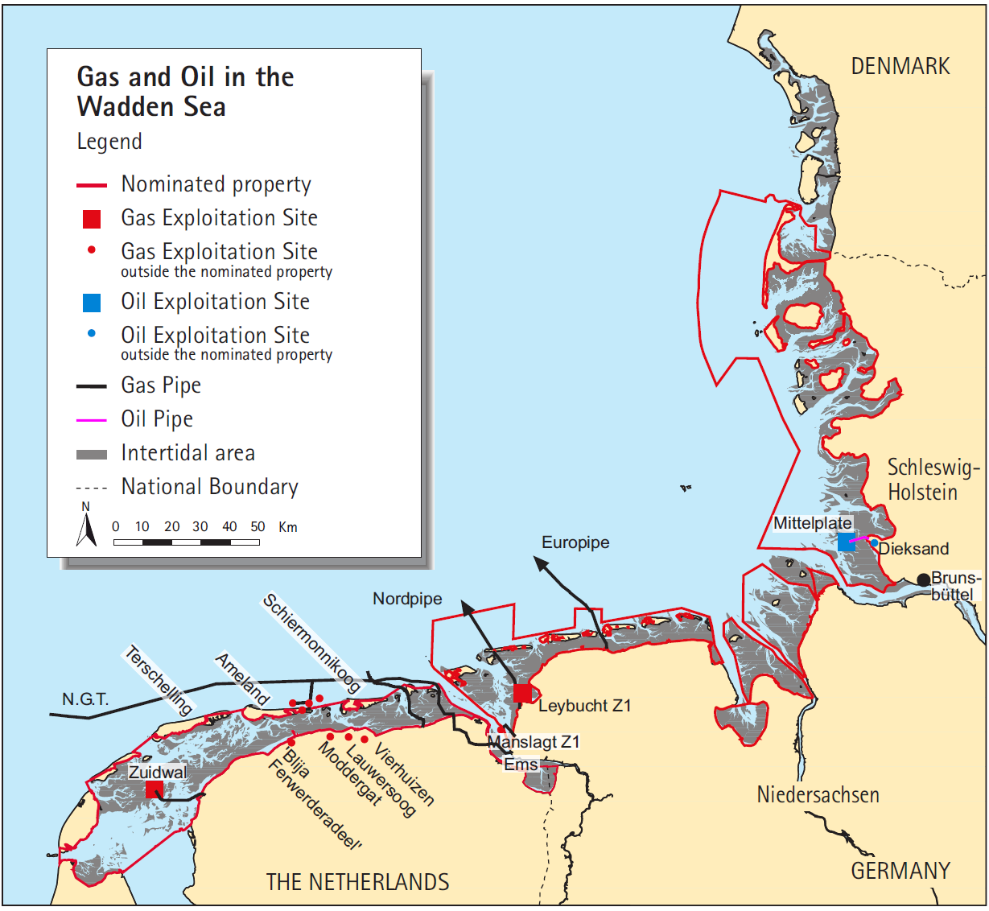
Figure 3. Gas and oil exploitation sites and pipes. Needs update?

Common ground
Trilateral agreements:

- In the Nature Conservation Area, new exploitation installations for oil and gas will not be permitted (WSP, 2010).

“For the area of the World Heritage property, Germany and The Netherlands have confirmed their commitment not to explore and extract oil and gas at locations within the revised boundaries of the nominated property in line with law in force” (WSP, 2010). In Denmark, “exploration and exploitation of gas and oil including seismic investigations is prohibited in the nominated property according to the Statutory Order on the Nature and Wildlife Reserve Wadden Sea” (Nomination Dossier, 2012).

- “New licenses for the construction of pipelines in the salt marshes for the transport of gas and oil shall not be issued unless in the absence of alternative solutions, a plan or project must nevertheless be carried out for imperative reasons of overriding public interest including those of a social or economic nature.
- The exploration and exploitation of the energy resources in the North Sea, as well as in the Wadden Sea Area, has to comply, at least, with the international agreements in the appropriate fora. This results inter alia in a prohibition on discharging oil-based muds and cuttings. Dumping or discharge of water based muds and/or cuttings is only allowed in line with relevant OSPAR agreements.
- Infrastructural works which are necessary for the supply of the islands and the Halligen with, amongst others, gas, water and electricity, or other utilities, shall be carried out in a way that the environmental impact on the Wadden Sea is kept to a minimum and permanent, or long lasting, impacts are avoided.
- The construction of pipelines shall be such that the environmental impact on the Wadden Sea ecosystem is kept to a minimum and permanent, or long lasting, negative impacts are avoided, and if this is not possible, compensated. In the Nature Conservation Area, new licenses for the construction of pipelines in the tidal area for the transport of gas and oil shall not be issued unless in the absence of alternative solutions, a plan or project must nevertheless be carried out for imperative reasons of overriding public interest, including those of a social or economic nature” (WSP, 2010).

These agreements are backed up with the legal framework presented in Table 3.

Table 3. Legal framework that regulates the oil and gas exploitation activities
 | Legal framework | Governance/Responsible Authority to grant permits | Enterprise (?)
Wadden Sea World Heritage property in…
…the Netherlands | Drilling for gas is prohibited by the PKB. It takes place from the shore outside the WSWH property with directional drilling using deviated wells, tapping into the gas reserves underneath the Wadden Sea. |  | Gas: …?
Lower Saxony | Regulated by the National Park Act | State Office for Mining, Energy and Geology | NA
Hamburg | Prohibited by the National Park Act | Hamburg Wadden Sea National Park (?) | NA
Schleswig-Holstein | Regulated by the National Park Act |  | Oil: Consisting of Deutsche Erdöl AG (sold by RWE to the Russian investment fund LetterOne in 2015) as the operating company and Wintershall Holding GmbH (QSR, 2017)
Denmark | Prohibited by the Statutory Order on the Nature Reserve Wadden Sea
Sources: QSR, 2017; Nomination Dossier, 2012.

Trends
New exploitation installations for oil and gas will not be permitted. Gas and oil exploitation will continue through directional drilling.
Threats Oil and Gas
Transfer cables to the coastline are laid through the Wadden Sea causing impact (QSR, 2017).

Sources of information
Nomination dossier (2008, 2014)
QSR (2017)
WSP 2010

Annex 1: Referential content structure for key topics Renewable energy, Energy from Oil and Gas, Coastal flood defense and protection
The joint SIMP meeting agreed to replace the title of this key topic from “Impacts from outside” to “Renewable energy”, “Energy from Oil and Gas” and “Coastal flood defense and protection”.
Heading | Description and considerations
Improve communication | It is desirable to improve communication, however, consider that policies are very different in the countries.
Inventory | An inventory of the legal framework regarding these topics in the three countries is needed.
Common ground | Statement from the WH Nomination Dossier.
OUV key value | Which OUV key value(s) is being affected positively or negatively by “Renewable energy”, “energy from Oil and Gas” and “Coastal flood defense and protection” activities? (see Annex 5: Statement of OUV for the Wadden Sea World Heritage Site and derived draft key values).
Threats and opportunities | Conduct a deeper analysis on the conflicts with the OUV key value(s).
Strategies and actions for management | Identify the existing or define new strategies and actions for managing the spotted threats and opportunities. Link to the existing management and monitoring tools: spatial planning, national strategies (for coastal protection), Wadden Sea Strategy, Code of conduct, Leeuwarden Declaration.
Monitoring, data collection and data management | Ask for support from TG-MA.
Climate change | Relation to and potential interaction with climate change.
Projects & Budget | In the future ideas of joint projects may arise while working on the topic.
Who | TG-M to propose working approach.
Next immediate steps |  | - Draft the content of the heading “Inventory” focusing on the legal framework, revise and improve.  - TG-M to propose working approach.

OUV key values are directly derived from the Statement of OUV of the Wadden Sea World Heritage Property. These key values are also being applied in the climate variability analysis (CVI).

