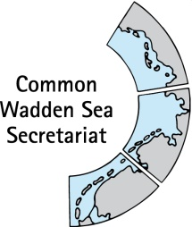
MEETING DOCUMENT
Task Group Management (TG-M 20-1)
17 - 18 April 2020
Bremen, Germany

Agenda Item: 7. Sustainable fisheries
Subject: Fisheries inventory and working approach Wadden Sea
Document No.: TG-M 20-1/7
Date: 4 March 20
Submitted by: CWSS

At the Wadden Sea Board (WSB) meeting 30 held on 21 November 2019 in Wilhelmshaven, Germany, the Board instructed TG-M to come forward with a proposal how to handle the issue of sustainable fisheries.
Following this instruction, TG-M agreed at their preliminary meeting in February 2020 to commission CWSS to produce an inventory, which gives an overview of the current situation/practices of sustainable fisheries based on the “Framework for sustainable fisheries” (Annex 3 Tønder Declaration), the QSR 2017 Thematic Report on Fisheries (Baer et al 2017), the corresponding paragraphs from the Tønder Declaration and the formerly requested update of the fisheries activities inventory from the regions (of TG-M 13 meeting in 2015).
In addition, this topic has been selected as key topic for the Single Integrated Management Plan (SIMP) for the Wadden Sea World Heritage property at WSB 30. Therefore, material may be used as basis for the inventory / common ground that was agreed to be developed for the Single Integrated Management Plan (SIMP) in the joint SIMP Meeting TG-M & TG-WH on 24 January 2020.
This document contains a draft inventory based on above given sources and a draft outline for discussion of status and a working approach towards sustainable fisheries in the Wadden Sea Conservation Area. This information and working approach may serve as input to the SIMP, see Agenda items 4 & 10.

Proposal: The group is invited to revise and adopt a working approach on this topic.

Sustainable fisheries in the Wadden Sea Conservation Area

Background
In their “Framework for sustainable fisheries” adopted as Annex 3 Tønder Declaration at the Trilateral Governmental Conference 2014 in Tønder, Denmark, it is stated that “Fishery activities should not significantly impact the integrity and function of the ecosystem, i.e. not deteriorate the natural habitats and species in the Wadden Sea and not impair the sustainability of fish stock. Fishing activities in the Wadden Sea Conservation Area should be carried out in accordance with the Guiding Principle”. In the same Annex, the Wadden Sea Board (WSB) identified a catalogue of principles, which require special attention for the implementation of sustainable fisheries.
In the following, a short draft inventory on fishery in the Wadden Sea Cooperation Area, as well as an outline for the current status and recommendation for each of the principles for sustainable fisheries are given, under consideration of the Thematic report on fisheries (Baer et al. 2017) and an inventory by the Task Group Management (TG-M) at their 13th meeting in 2015.
In addition, a draft proposal for a working approach is given, which should be aligned with the TG-M responsibilities for the key topic Fishery in the Single Integrated Management Plan (SIMP) for the Wadden Sea World Heritage property.

Draft Fishery Inventory for the Wadden Sea Cooperation Area
Commercial fisheries in and adjacent to the Wadden Sea concentrate on brown shrimps (Crangon crangon) and mussels (predominantly blue mussels Mytilus edulis), while small-scale fisheries include cockles (Cerastoderma edule) (Baer et al. 2017). A recent overview on fishery of shellfish has been published in the Fisheries Thematic Report of the QSR (Table 1).
A draft overview on shrimp fishery based on the TG-M inventory 2015 and the QSR Thematic Report on Fishery has been compiled by CWSS (Table 2). Data on brown shrimp fishery, however, are usually given for the entire North Sea region, as this resembles the brown shrimp population. In 2017, shrimp fishery in the Wadden Sea has been certified by the Marine Stewardship Council (MSC) Sustainable Fisheries (Addison et al 2017) which also implies new developments and information for the Wadden Sea Conservation Area, including a Brown Shrimp Management Plan. The Unit of Certification for the MSc covers Dutch, German and Danish vessels catching brown shrimp in the North Sea by use of lightweight beam trawls. Recently, the first MSC surveillance report has been submitted (Addison et al 2019), which includes an updated version of the Brown Shrimp Management Plan.
Also, a first draft of facts on non-commercial fishing in the Wadden Sea with input from TG-M 2015 has been compiled (Table 3), as well as an entire overview about fishery by TG-M 2015 in form of a table (Table 4).

Outline for status and recommendations for principles of the Framework Sustainable Fishery: six years after Tønder

Appropriate assessment or equivalent impact assessments Within the framework of relevant EU legislation (e.g. the Habitats Directive, the Bird Directive, the Marine Strategy Framework Directive and the Water Framework Directive), assessments should be applied to all fisheries sectors in the Wadden Sea. This should be done as an exchange of knowledge and experiences trilaterally in relation to impact assessments, with the aim to secure comparable methods and standards between the trilateral countries. These assessments must be based upon nature conservation objectives, specified to the extent possible, scientifically robust, trilaterally comparative and transparent. The use of regular impact assessments by all Wadden Sea regions would also level the playing field and may facilitate the dialogue between the fishery managers, the industry and environmental NGOs at a trilateral level
Status: TBD. Note: Dialogue on brown shrimp fishery by Joint Working Group (NGOs, fishery) on-going in course of MSC surveillance.
Recommendation for management action for the upcoming five (?) years: TBD
Fishing gear/best practice The application of appropriate fishing gear and best practices is another essential element in operationalizing sustainable fisheries, in particular with the aim of reducing impacts on the bottom and reducing bycatch. Best practice is understood to be a combination of fishing techniques and fishing effort, minimising impacts. A detailed analysis of fishing gear (application, site specific impact) may be part of the dialogue with the stakeholders. The fishing industry should be encouraged to develop more sustainable techniques and practices.
Status: Alternative techniques with potentially less impact to the ecosystem are under development, as well as corresponding national management and protection regimes (Baer et al. 2017). In the course of MSC certification, the mesh size is intended to increase from originally 20 mm to 24 mm according to the Brown Shrimp Management Plan. The CRANIMPACT project on impacts of shrimp fisheries on habitats and communities in the coastal seas of the Federal States of Schleswig-Holstein, Hamburg and Lower Saxony is on-going (2018 – 2022) (Thünen Institute 2020).
Recommendation for management action for the upcoming five (?) years: TBD
Closed areas Closed areas are a management option for sustainable fisheries in the Wadden Sea Conservation Area, in particular to allow natural processes to proceed in an undisturbed way, to achieve the conservation objectives and biodiversity and in cases where there is insufficient knowledge about impacts. Sufficiently large closed areas can also serve as reference and recovery areas. The designation of such areas is in the responsibility of the national state, taking into account the relevant EU regulations.
Status: Fishery is strongly regulated and vast areas are closed for shrimp and mussel fishing activities, with different extent over the three countries. Denmark has banned shrimp and mussel fishery entirely (Figure 1)(Baer et al. 2017). Closed areas were, however, not completely avoided by brown shrimp fishery (German vessels, 2007 – 2013) (Kuechly et al. 2016).
Recommendation for management action for the upcoming five (?) years: TBD

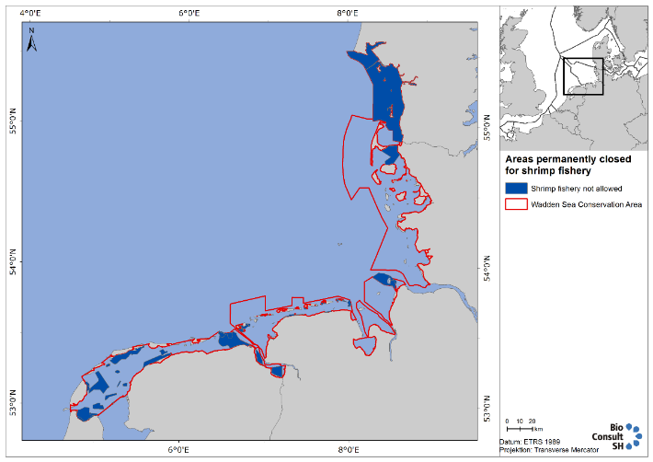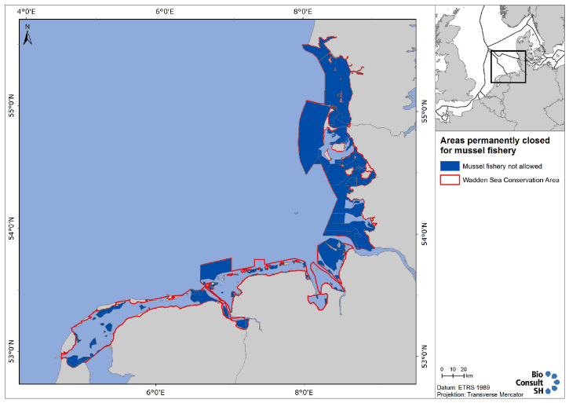
Figure 1: Maps showing Wadden Sea areas closed year-round (dark blue) in Wadden Sea Conservation Area (red line): left: shrimp fishery; right mussel fishery. The map on mussel fishery includes future closed areas in Schleswig-Holstein when the updated management plan comes into effect (Source: figures 4 and 9 of QSR thematic report on fishery).

Monitoring/control/black box This includes monitoring of fishing activities and the status of fished and closed areas. The fisheries sector is co-responsible for monitoring of fishing activities. Black boxes, or equivalent systems (e.g. VMS), are an important precondition for co-management, including nature protection.
Status: TBD
Data from Automatic Identification System (AIS) messages show low to very high fishing intensity in the Wadden Sea Cooperation Area (JRC, compare Figure 2). Fishing activity of members (MSC) are monitored through VMS mapping every year to monitor the risk of any expansion into sensitive habitats (vessel Monitoring System (VMS) plots for brown shrimp fishery are provided for the Netherlands, Germany and Denmark within the MSc certification process, compare figure 8 in Addison et al 2019).
Recommendation for management action for the upcoming five (?) years: TBD
Stock assessment Regular stock assessments must be carried out to serve as a basis for stock management as clarified in the EU Common Fisheries Policy and other relevant EU legislation. This is an essential element for sustainable fisheries. Fishing impact should be such that stable food webs are restored and maintained, supporting natural populations of predators.
Status: TBD.
Until 2016 there were no annual stock assessments for brown shrimps in the North Sea, yet there are signs of growth overfishing for this species (Tulp et al 2016). For this short-lived species, a conventional age-based stock assessment is not possible. “ICES advised that the development of a harvest control rule (HCR) based on a comparison of the most recent commercial landings per unit effort (LPUE) data with pre-defined trigger levels (based on previous LPUE data) was the most appropriate approach for this short-lived species. ICES also advised that Crangon should be taken into account within the framework of ICES advice regarding North Sea mixed fisheries because of the significant bycatch of other species in the small-meshed net Crangon fisheries, and in relation to multispecies interactions because future recovery of gadoid populations could have an impact on shrimp population dynamics” (Addison et al 2019).
It is unclear, if fishing pressure would reduce shrimp availability to predators (Tulp et al 2016).
Recommendation for management action for the upcoming five (?) years: TBD
Appropriate knowledge<>responsibility of all parties involved In the process of operationalizing sustainable fisheries, use must be made of best available knowledge. There is a responsibility of all parties involved in supporting knowledge about the status of the ecosystem.
Status: TBD
Recommendation for management action for the upcoming five (?) years: TBD
Pilot studies (learning by doing) Transition towards sustainable fisheries also implies that there must be ample possibilities for testing new methods and practices. Knowledge gained in pilots should be spread among all parties involved
Status: TBD
Several projects have been and are being conducted. Amongst them is CRANNET (Thünen Institute 2020), in which improvement of cod end selectivity (result: cod ends with T0 or T90 meshes and a mesh size of 26 mm or square mesh cod ends (T45) with a mesh size of 24 mm were identified to increase the sustainability of brown shrimp fisheries in terms of ecological and economic aspects) and reduction of by-catches in brown shrimp fishery were in the focus from 2012 – 2015.
Recommendation for management action for the upcoming five (?) years: TBD

Proposal for working approach Fishery
The proposal for a working approach for the topic Sustainable Fishery is of relevance for the Tønder: Framework Sustainable Fisheries, as well as for the SIMP (compare TG-M work plan, document TG-M20-1/4), as well as for the Leeuwarden Declaration Paragraphs
Proposal how to handle the issue of sustainable fisheries (to be submitted to WSB 31 meeting June 2020)
- Update and completion of fishery inventory – level of detail TBD
- Status and recommendations for principles Framework Sustainable Fishery
Product 1: Inventory on fishery in the Wadden Sea Conservation Area.
Product 2: Document on Framework Sustainable Fishery with status and recommendations for upcoming Trilateral Governmental conference.
Both products will feed into the SIMP.

Table 1. Facts on current shellfish fishing (source QSR 2009, updated)(Table content: Baer et al. 2017, footnotes added).

 | Netherlands | Lower Saxony | Schleswig-Holstein | Denmark
Blue mussel fishery
Average annual Mussel landings 2009-2015 (t) | Wadden Sea 19 313 t | 3 857 t | 5 770 t
 | Oosterschelde 24 552 t | (culture + wild) | (from culture lots)
 | (from culture lots)
Mussel culture in use (ha) | 4 000 | 1 300 | 2 000 | None
Number of Licenses* | 89 (seed fishing vessels) | 5 (vessels) | 8 (vessels) | None
 | 82 mussel culture
Quota | For seed mussels | None | None
Permanently closed area (ha) | 42 540 | 93 480 | 135 000 | All of Danish Wadden Sea Zone
 | (this area covers 18 % of total intertidal stock) | (this area covers about 10 % of total area of intertidal mussel beds) | (this area covers 100 % of intertidal mussel beds)
Additional restrictions | Intertidal: Seed fishery on unstable mussel beds only if at least 2000 ha of 1-year old mussel beds are left. Use of black box system. | Additionally 17 sites closed in accordance with Management Plan (about 10 % of intertidal mussel beds) | Min. size 40 mm, use of black box system, seasonal closure for spat 01.05-30.06 and for harvest mussels 15.04-30.06
 |  | Min. size 50 mm (wild)
 |  | Seasonal closure for intertidal areas 15.12.-31.03
 |  | Use of black box system
Cockle fishery
Average annual cockle landings (tons wet weight) | Mechanical: no landings since 2005 | No landings since 1999 | No landings since 1989 | No landings since 2008 except trial fishery in 2016
 | Non-mechanical: 600 tons of meat average annual harvest 2005 - 2013
Number of licenses/vessels for cockle fishery | Maximum of 31 licenses for manual cockle fishery | None | None | 1
 | (30 actively used)
Permanently closed area (ha) | 42 540 | 100 % of conservation area | 100 % of conservation area | 99 % of conservation area
Additional restrictions for cockle fishery | Min. size 15 mm. |  |  | Min. size 16 mm, total landing limit of 2000 t
 | Maximum yearly catch: 2.5 % of the cockle stock
Spisula fishery
Spisula landings, annual average in tons fresh weight (period) | No landings since 2001 | No landings since 1996 | No landings since 1995 | No landings since 2003
Oyster fishery
Oyster culture | Not practiced | Not practiced | 1 oyster culture lot, min size 50gr | Not practiced
Oyster collection | hand picking of intertidal pacific oysters is allowed for 18 permit holders | Not practiced | only hand picking on max. 450 ha intertidal in zone 2 with max. 10 persons at the same time. | Not practiced**
* include details to content of licenses? ** to be amended? in TG-M 13 (2015) inventory, the following information is given: “A project with experimental fishing for Gigas oysters has been initiated with one fishing license. Fishing has not started yet. It may only take place in mussel production areas 132 and 135. The quantity is 750 tons”.

Table 2. First draft of facts on shrimp fishery in the Wadden Sea (based on Baer et al. 2017 and TG-M 2015). Besides national measures, brown shrimp fishery is managed through EU regulations and through the Brown Shrimp Management Plan, which sets out details of the harvest strategy including harvest control rules (HCRs), an ecosystem approach to management of the fishery, and the regulations applying to the fishery.
 | Netherlands | Lower Saxony | Schleswig-Holstein | Denmark
Shrimp fishery
Average annual shrimp landings 2009-2015 (t)* | TBD possible for Wadden Sea or North Sea only? | TBD possible for Wadden Sea or North Sea only? | landings of the SH shrimp fishery range annually between 6000 and 6800 tons | None
Number of Licenses | 87 licenses for shrimpfishing in the Waddensea | approx. 120 licenses given by the BLE (Bundesanstalt für Landwirtschaft und Ernährung) for fisheries on shrimps. | west coast of Schleswig-Holstein 74 commercial shrimp fishing boats. Additional 52 smaller vessels are operated by part time fishermen (Nebenerwerbsfischer) | None
Quota | Traditionally no quota (Baer et al 2017), Harvest Control Rules (HCRs) in Brown Shrimp Management Plan? | Traditionally no quota (Baer et al 2017), Harvest Control Rules (HCRs) in Brown Shrimp Management Plan?? | Traditionally no quota (Baer et al 2017), Harvest Control Rules (HCRs) in Brown Shrimp Management Plan? | None
Permanently closed area (ha) | TBD | NUMBER (ha) some core zones by law of the national park | NUMBER (ha) not in zero use area. In southern part of the Nationalpark time based voluntary regulations in the shelduck moulting areas | Entire Danish Wadden Sea area was closed to fishing in 1977 and the regulation is still in force
Additional restrictions | On the basis of the agreements as given in the Convenant VISWAD (Nature-NGOs, Government and Shrimp fishery sector) the shrimp fishery sector will apply for the necessary Nature Protection permit. Horizon of the VISWAD is 2026. The ambition for 2020 is to reduce the impact of shrimp fishery with 50%, a.o. by reduction of the fleet by 20-30%, using best-available –techniques, closed areas.
* 32,661 tons in the North Sea in 2019 for MSC fishery (https://fisheries.msc.org/en/fisheries/north-sea-brown-shrimp)

Table3. First draft of facts on non-commercial fishing in the Wadden Sea (input TG-M 2015).
 | Netherlands | Lower Saxony | Schleswig-Holstein | Denmark
Non-commercial fishing
 | For personal use it is allowed to take 10 kg/day of shellfish. | By National park law all kinds of recreational fishing is forbidden in the core zones of the national park. In contrast noncommercial fishing is allowed without a license in the intermediate and the recreational zone of the national park. This includes the collection of blue mussels and oysters for private use | All persons with a fishing license (which is needed in Schleswig-Holstein e.g. for angling) are allowed, within a general administrative regulation of the Nationalpark Law to collect oysters and blue mussels for private use. This use is restricted to zone 2 and the coastal strip of zone 1. The amount is limited to a maximum of 10 liters per day. This is according to our experience, a rare activity | Recreational fishing is allowed in the Danish part of the Wadden Sea when a fishing license has been purchased. Collection of mussels and oisters is allowed without fishing license

Table 4: Comprehensive inventory on fishery in the Wadden Sea Conservation Area 2015 (Original text TG-M 2015).
 | Denmark | Schleswig-Holstein | Lower Saxony | Netherlands
Type
Shrimps (Crangon crangon) | (subtidal)  There has been issued 32 licenses for fisheries on horse shrimps. By regulations beam trawl fisheries for shrimp can only take place 3 nautical miles outside the low-water line. South of Skallingen peninsular it is not allowed to fish for shrimps within the Islands.  Due to conservation concerns, the entire Danish Wadden Sea area was closed to fishing in 1977 and the regulation is still in force. | Along the west coast of Schleswig-Holstein licenses have been issued for 74 commercial shrimp fishing boats. In addition 52 smaller vessels are operating by part time fishermen (Nebenerwerbsfischer). Most commercial fishing boats are also able to fish on fish. Fishery is allowed within the most parts inside the Nationalpark except in the zero use area, which is marked red in the map. Within the southern part of the Nationalpark there are time based voluntary regulations in the shelduck moulting areas. The landings of the SH shrimp fishery range annually between 6000 and 6800 tons. | There are approx. 120 licenses given by the BLE (Bundesanstalt für Landwirtschaft und Ernährung) for fisheries on shrimps. By the law of the national park it is forbidden to fish shrimps in some core zones (see red zones in fig. 1) | On the basis of the agreements as given in the Convenant VISWAD (Nature-NGO’s, Government and Shrimpfishery sector) the shrimpfishery sector will apply for the necessary Nature Protection permit.  Horizon of the VISWAD is 2026. The ambition for 2020 is to reduce the impact of shrimp fishery with 50%, a.o. by reduction of the fleet by 20-30%, using best-available –techniques, closed areas.  There are 87 licenses for shrimpfishing in the Waddensea.
Fishing applying nets | (subtidal)  Within the islands in the Danish part of the Wadden Sea, it is allowed to use fyke nets for catching fish. There is a general prohibition on gillnets, re. concluding note.
Blue mussels Mytilus edulis | Subtidal: There is no blue mussel fishery in the Danish part of the Wadden Sea. | Blue Mussel fishery is regulated by the Fishery Law and the Nationalpark-Law of Schleswig Holstein and based on a mussel-fishery-program. The current program is running since 2011 until the end of 2026.  In principle an amendment of mussel fishery regulations has been agreed jointly between the mussel fishery sector, NGOs and the ministry and is expected to come into force within an adapted program in 2016 (until 2030).  The basics of the existing regulations are:  Blue mussels (all activities restricted to the subtidal):  •The area of mussel culture lots is restricted to 2000ha outside of zone 1, of which a reduction of 100ha for compensation measures (according to the habitat directive) is possible,  •Additional 300ha of the subtidal (outside zone 1) can be used for mussel seed collectors (which is under dispute, permission has been given until now for 60ha, the permission has been brought to court by nature NGOs),  •Seed mussel fishery is only permitted in the subtidal outside of zone 1 (with possibilities to fish in two zone 1 areas in “urgent” cases),  •Import of seed mussels is forbidden by highest court judgment.  Cornerstones for the amendment of blue mussel fishery regulations as agreed in 2015 by mussel fishery sector, NGOs and the ministry (expected to come into force from 2016 until 2030):  The basics of the coming mussel fishery program are | Blue mussel fishery in Lower Saxony (5 vessels) is regulated by fisheries law and the national park law. The seed-mussel fishery is allowed in the frame of a management plan (since 1999). This management plan (valid time: 5 years) is a central part of the law to regulate the seed mussel fishery. The plan contents:  -29 closed blue mussel sites for blue mussel fishery (total number of sites 102, closed by law 12, closed by management plan 17)  -1.000ha of mussel beds and 10.000 t biomass have to remain in the whole national park (otherwise the fishery has to be stopped)  -Regulations and permissions for installing alternative collectors for mussel seed  -The fishery on consumption mussels on the intertidal areas is not allowed.  A new management plan is still in progress. Probably it will content more regulations for the fishery on blue mussels and for the import of mussel seed. | Subtidal. Intertidal under conditions: 26% of the intertidal is closed and a min. of 2000 ha of stable (>1 year old beds) should remain.  Culture lots are licensed. More than 7000ha; actually 3300 ha are in use.  Since 2009 subject to conditions described in the convenant towards sustainable mussel fisheries and nature recovery (Horizon 2020). Therefore the fishery sector should realize non-soil-contacting seed mussel fishing, by using artificial seed collector farms (now 8 operational) or by importing from the South-Western Delta subject however to additional rules and regulations..  Sector needs twice a year a license, based on actual stock assessments.  93 mussel fishing licenses operational (2012)
Common cockles and Spisula | (subtidal) A single vessel is allowed to fish common cockles and Spisula. Common cockles can be fished in an area, bordered in the north by latitude 55 ° 36'N and in the south by the Danish German maritime border. However, the fisheries must take place outside the 3 mile limit at depths greater than 6 meters and not between the parallel of latitude of 55 ° 12'N and 55 ° 20'N. Spisula can be fished in an area, bordered to the north by latitude 56 ° 14'1N and south of latitude 55 ° 50'00 N. However, the fisheries must take place outside the 1-mile of the low-water line. | •Fishery for other mussels is not allowed in the Nationalpark, with one exception:  oIn principle the fishery of thick trough shells (Spisula solida) is allowed outside the 3sm zone. However, for many years this has not occurred and will be terminated completely at the end of 2016. | There is no cockle fishery or other mussel fishery in the National park in Lower Saxony | Hand raking for cockle fishery is allowed in the intertidal. Total amount may not exceed 5% of total cockle stock.  32 permits are issued. Areas and fishing activity is limited/controlled, following the agreement reached between cockle industry, nature NGO’s and government (2011). In spring a survey is conducted on stock availablility.
Pacific oysters Crassostrea gigas | A project with experimental fishing for Gigas oysters has been initiated with one fishing license. Fishing has not started yet. It may only take place in mussel production areas 132 and 135. The quantity is 750 tons | •There is one permit for oyster culture (30ha) east of the island Sylt. New permits will not be granted.  •Collecting seed mussels (for the oyster culture) in the intertidal is permitted in zone 2, restricted to an area of max. 450ha (which is 1% of the intertidal of zone 2). Permission is only for collection by hand with a maximum number of 10 persons per selected area at the same time. Collection is not permitted in areas with a mixture of blue mussels and pacific oysters.  •Collection (by hand) of adult oysters (more than 50g flesh weight) for commercial use is granted in 7 selected areas by a maximum of 7 single licenses. Presently 2 licenses have been given (one of them comprises several selected areas), which totally cover 400 ha. | There is no oyster fishery in the Lower Saxony part of the Wadden Sea (only as a bycatch during the commercial blue mussel fishery). | On a pilot basis, experimental fishery on Pacific oyster takes place by manual collection (15 people)
Non-commercial fishing | sub- an intertidal)  Recreational fishing is allowed in the Danish part of the Wadden Sea when a fishing license has been purchased. Collection of mussels and oisters is allowed without fishing license | All persons with a fishing license (which is needed in Schleswig-Holstein e.g. for angling) are allowed, within a general administrative regulation of the Nationalpark Law to collect oysters and blue mussels for private use. This use is restricted to zone 2 and the coastal strip of zone 1. The amount is limited to a maximum of 10 liters per day. This is according to our experience, a rare activity | By National park law all kinds of recreational fishing is forbidden in the core zones of the national park. In contrast noncommercial fishing is allowed without a license in the intermediate and the recreational zone of the national park. This includes the collection of blue mussels and oysters for private use. | For personal use it is allowed to take 10 kg/day of shellfish.
OTHER (Specific regulations,) | Specific regulations for fishery in the Danish part of the Wadden Sea has been laid down in a regulatory announcement: “Specific rules of fishery and conservation areas in the Wadden Sea and in certain streams in South Jutland” | .

Figure 2: This map of fishing intensity allows to explore in great detail the intensity of fishing activity over all EU waters. The data analysed to create this map consists of around 150 million positions reports from EU fishing vessels above 15 m of length, operating in the Food and Agriculture Organisation (FAO) areas 27, 34 and 37, in the period between September 2014 and September 2015. Each Automatic Identification System (AIS) message provides the position of the vessel, its speed and a timestamp, at intervals of five minutes. These messages were classified as either related to fishing or to steaming through a classification algorithm based on the analysis of individual vessels speed profiles. Source: https://ec.europa.eu/maritimeaffairs/atlas/maritime_atlas/#lang=EN;p=w;bkgd=5;theme=259:1.00;c=768452.8694627886,7217754.767499402;z=8;e=t
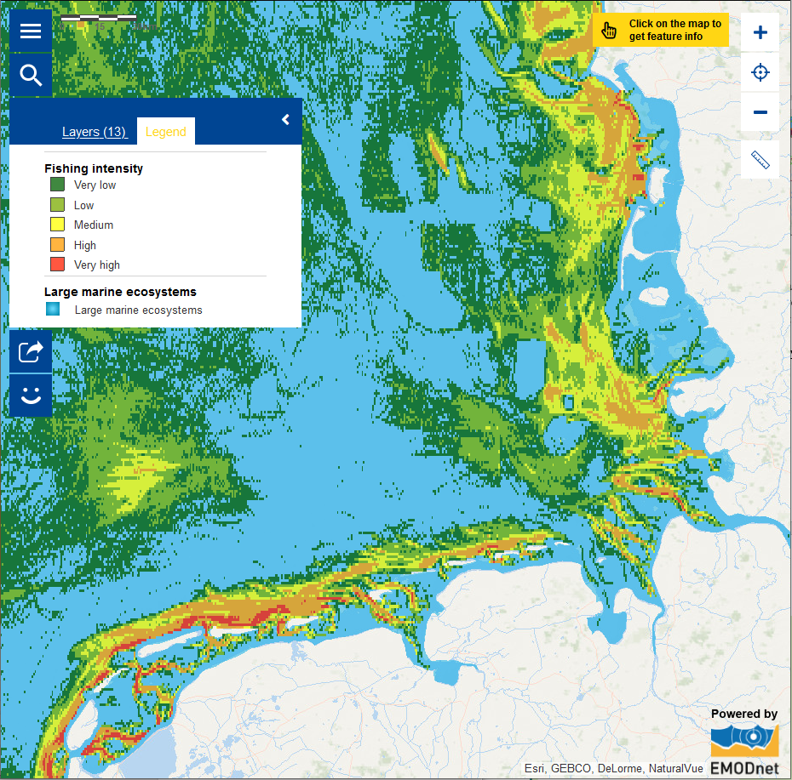

References
Addison J, Gaudian G, Knapman P (2019) MSC 1st surveillance report Final revised (1) North Sea Brown Shrimp. Marine Stewardship Council fisheries assessments. 80 pages.
Addison J, Gaudian G, Knapman P (2017) MSC sustainable fisheries certification North Sea Brown Shrimp – Public Certification Report. 428 pages.
Baer J., Smaal A., van der Reijden K. & Nehls G. (2017) Fisheries. In: Wadden Sea Quality Status Report 2017. Eds.: Kloepper S. et al., Common Wadden Sea Secretariat, Wilhelmshaven, Germany. Last updated 21.12.2017. Downloaded 2020-03-04. qsr.waddensea-worldheritage.org/reports/fisheries
Kuechly H, Liebich V, Rösner HU (2016) Wo die Krabben gefischt werden – Räumliche Verteilung und zeitliche Entwicklung bei der Nutzung des Wattenmeeres und der angrenzenden Nordsee durch die deutsche Krabbenfischerei von 2007 bis 2013. WWF Deutschland, Berlin, Germany. URL: http://mobil.wwf.de/fileadmin/fm-wwf/Publikationen-PDF/WWF-Bericht-Wo-die-Krabben-gefischt-werden-kleine-Fassung.pdf
Thünen Institute (2020) CRANIMPACT project: Impact of brown shrimp fishery on benthic habitats Accessed at 2020-03-04. URL: https://www.thuenen.de/en/cross-institutional-projects/optimised-brown-shrimp-fishery-crannet/
Thünen Institute (2020) CRANNET project: Optimised brown shrimp fishery. Accessed at 2020-03-04. URL: https://www.thuenen.de/en/cross-institutional-projects/optimised-brown-shrimp-fishery-crannet/
Tulp I, Chen C, Haslob H, Schult K, Siegel V, Steenbergen J, Temming A, Hufnagl M (2016) Annual brown shrimp (Crangon crangon) biomass production in North western Europe contrasted to annual landings. ICES Journal of Marine Science. 13p. doi i:10.1093/icesjms/fsw141

