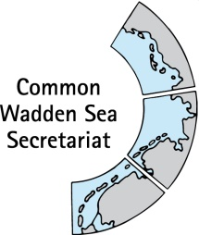
MEETING DOCUMENT
Expert group Climate Change Adaptation (EG-C 5)
22 April 2020
Virtual meeting

Agenda Item: 6. Single Integrated Management Plan (SIMP)
Subject: Coastal Flood defence and Protection
Document No.: EG-C 5/6
Date: 29 April 20
Submitted by: CWSS, chair EG-C

At the Wadden Sea Board (WSB) meeting 30 held on 21 November 2019 in Wilhelmshaven, Germany, the Board endorsed the key topics for the Single Integrated Management Plan (SIMP): fisheries, tourism, shipping and impacts from outside (specifically renewable energy, energy from oil and gas and coastal flood defence and protection).
In their Joint SIMP meeting on 23 January 2020 in Hamburg, Task Groups Management (TG-M) and World Heritage (TG-WH) discussed and agreed on a referential structure for each key topic and on the next steps to develop the content. The identified next steps for the key topics are to draft the content of the heading “Inventory” and “Common ground” focusing on the legal framework to revise and improve.
While TG-M is responsible for the chapter on impacts from outside, TG-M agreed at their meeting on 17 March 2020 that “Coastal flood defence and protection” should be presented in a separate chapter and should be prepared by the Expert Group Climate Change Adaptation (EG-C).
This document contains a draft of two headings of the agreed referential content structure for Coastal flood defence and protection “Inventory” and “Common ground” as a first draft content to discuss upon, revise and improve. Specific questions for EG-C are:
- Which are good examples of integration of coastal protection with other interests (nature)?
- Fact check and add to table with “coastal protection”facts
- Fact check and add to overview of laws / legislation
Note: the entire SIMP will be a document of 40 pages, but it will be considered to provide more extensive information as online document. This limitation to 40 pages will be discussed at the next Wadden Sea Board meeting. Discussion at the EG-C meeting may lead to recommendations to the WSB regarding the level of detail needed for the SIMP.
Proposal: The group is invited to revise and comment to the draft.

Single Integrated Management Plan (SIMP) – Chapter Coastal Flood Defence & Protection

The SIMP: excerpt of draft introduction and purpose
In over 40 years of trilateral cooperation between Denmark, Germany and the Netherlands, some of the most urgent and important key aspects have been addressed and management is in place. The Wadden Sea Plan 2010 is the common policy and management plan for the protection and sustainable management of the Wadden Sea Area, including the World Heritage. Additionally, there are various trilateral, regional and local strategies, management plans, plans of actions and networks. In short, much has been achieved, a very high percentage of what needs to be done is on its way, though there are still serious shortcomings (Managers Recommendations, 2019).
The development of a Single Integrated Management Plan (SIMP) responds to the request from the World Heritage Committee in 2014 to “the State Parties of Denmark, Germany and the Netherlands to develop a single integrated management plan for the entire transboundary property in conformity with the requirements of Paragraph 111 of the Operational Guidelines, and to consider the options to strengthen the effectiveness of implementation of coordinated management within the property;”
Purpose of the SIMP:
With the diversity of management systems and instruments that are in place in the Wadden Sea World Heritage (WSWH), the purpose of the SIMP is to further facilitate the continuous improvement of management coordination for the protection and maintenance of the Outstanding Universal Value by:
- providing a clear overarching sight of the management system at the regional, national and trilateral level;
- addressing some of the aspects that need ongoing attention and are more challenging to address since most of the planning and management takes place in other ministries and agencies outside the ones that have been and are part of the Trilateral Wadden Sea Cooperation (TWSC).

Background on the SIMP process and chapter coastal flood defence & protection
Wadden Sea World Heritage (WSWH) Managers and the Task Group World Heritage (TG-WH) identified “Impacts from Outside” as a key topic for the Single Integrated Management Plan (SIMP), also endorsed by the Wadden Sea Board (WSB) 30. The joint SIMP meeting (Task Group Management (TG-M) and TG-WH) agreed on a referential content structure (Figure 1) and to treat the key topic “Impacts from outside” with “Renewable energy”, “Energy from Oil and Gas” and “Coastal flood defence and protection”. While TG-M is responsible for the chapter on impacts from outside, TG-M agreed at their meeting on 17 March 2020 that “Coastal flood defence and protection” should be presented in a separate chapter and should be prepared by the Expert Group Climate Change Adaptation (EG-C).
In the SIMP content structure (Annex), key topics are treated under 5. What to manage (key topics), 5.5. Coastal and flood defence and protection.
The following draft text addresses “Coastal flood defence and protection” based on the QSR 2017 Thematic Report on Coastal Risk Management (Zijlstra et al 2017), the World Heritage Nomination Dossiers as well as on the CPSL Third Report (CPSL, 2010). This draft is a basis for further reflection on the level of detail needed and wanted in the content of the headings “Inventory” and “Common ground”, as well as for identifying whether there is the need to update certain information and if there is additional relevant information that needs to be considered.

Draft timeline for SIMP chapter on coastal flood defence and protection
“Coastal flood defence and protection” should be presented in a separate chapter, following the referential content structure for key topics (Table 1).
Time | What | Responsible
2020-04 | First draft Content on SIMP headings “Inventory” and “Common ground” | Zijlstra, Busch
2020-05 | Draft Content on SIMP headings “Inventory” and “Common ground” | EG-C
2020-05 | Share Draft Content on SIMP headings “Inventory” and “Common ground” with TG-WH and TG-M
2020-06-18 | WSB 31 First draft content of SIMP (one key topic exemplary)
2020-09 | Revision Content on SIMP headings “Inventory” and “Common ground” | EG-C, TG-WH, TG-M
2020-06 – 2020-09 | First draft "Strategies and actions for management" based on "Threats and opportunities" and considering "Climate change" | EG-C
2020-09 | Revision "Strategies and actions for management" based on "Threats and opportunities" and considering "Climate change | EG-C, TG-WH, TG-M
2020-11-19 | WSB 32: First draft of entire SIMP
TBD | Monitoring, data collection and data management | EG-C & TG-MA?

Table 1 Referential content structure for key topics Renewable energy, Energy from Oil and Gas, Coastal flood defence and protection. It was agreed in the joint SIMP meeting to replace the title of this key topic from “Impacts from outside” to “Renewable energy”, “Energy from Oil and Gas” and “Coastal flood defence and protection”.
Heading | Description and considerations
Improve communication | It is desirable to improve communication, however, consider that policies are very different in the countries.
Inventory | An inventory of the legal framework regarding these topics in the three countries is needed.
Common ground | Statement from the WH Nomination Dossier.
OUV key value | Which OUV key value(s) is being affected positively or negatively by “Renewable energy”, “energy from Oil and Gas” and “Coastal flood defence and protection” activities? (see: Statement of OUV for the Wadden Sea World Heritage Site and derived draft key values).
Threats and opportunities | Conduct a deeper analysis on the conflicts with the OUV key value(s).
Strategies and actions for management | Identify the existing or define new strategies and actions for managing the spotted threats and opportunities. Link to the existing management and monitoring tools: spatial planning, national strategies (for coastal protection), Wadden Sea Strategy, Code of conduct, Leeuwarden Declaration.
Monitoring, data collection and data management | Ask for support from TG-MA.
Climate change | Relation to and potential interaction with climate change.
Projects & Budget | In the future ideas of joint projects may arise while working on the topic.
Who | TG-M to propose working approach.
Next immediate steps |  | - Draft the content of the heading “Inventory” focusing on the legal framework, revise and improve.  - TG-M to propose working approach.

Draft: 5.5 Coastal flood defence and protection
The Wadden Sea World Heritage property stretches along about 500 km of coastline, with a multitude of transitional zones between the land, the sea and freshwater environment. About 3.5 million inhabitants live in the Wadden Sea region and are dependent on effective and reliable coastal risk management (CPSL, 2010). Major features representing the OUV of the Property are determined by a dynamic exchange of sediments, determined by tidal asymmetry and wave action, settling lag and overwash. Therefore, availability of sand and its re-distribution determines stability and integrity of the Wadden Sea region (CPSL; 2010).
Inventory
In all three countries the lower lying lands are generally protected by dikes. Further, all three countries intend to generally keep the coastline on the (inhabited) islands to safeguard functions. A large variety of coastal protection measures are applied in the Wadden Sea region, including dike building and strengthening, sand nourishments, dune management, salt marsh management techniques, mussel and sea-grass beds, outbanking summer polders and sea dikes.
The main dikes are generally managed as rather strict and “secure” lines. These man-made dikes form the basis for coastal flood defence and protection (Figure 5.5-1). Additionally, dams, revetments and bed protections are present. The Wadden Sea islands are protected by – more or less - natural dune systems on the North Sea side. These systems are sometimes supported by sand nourishments (mostly in the Netherlands). On some island locations, additional hard construction works are used to prevent erosion, as well as sand nourishments (Zijlstra et al 2017).
In Germany and the Netherlands, continuous reinforcements for dikes are undertaken. This is necessary to meet the safety standards including new technical insights and to prepare for sea level rise. Since 2007, no sea defences in the Danish Wadden Sea have been reinforced (check with DK).
Although safety of inhabitants and economic functions must be safeguarded, the value of the landscape and nature should always be considered when taking measures for coastal risk management near the World Heritage Site. The Guiding Principle of the Trilateral Wadden Sea Cooperation, “to achieve, as far as possible, a natural and sustainable ecosystem in which natural processes proceed in an undisturbed way” should always be considered when strengthening dikes or dunes. The responsible authorities for coastal risk management in the Wadden Sea are generally well aware of this. Good efforts have been made to integrate coastal risk management with nature conservation and other interests. However, interest are sometimes conflicting; for instance when space within the World Heritage property is needed to take the required measures.
In all three countries the EU Natura 2000 law and Habitat and Birds directive are effective for the Wadden Sea. This means that all measures for coastal protection have to comply with several nature conservation goals within this framework.
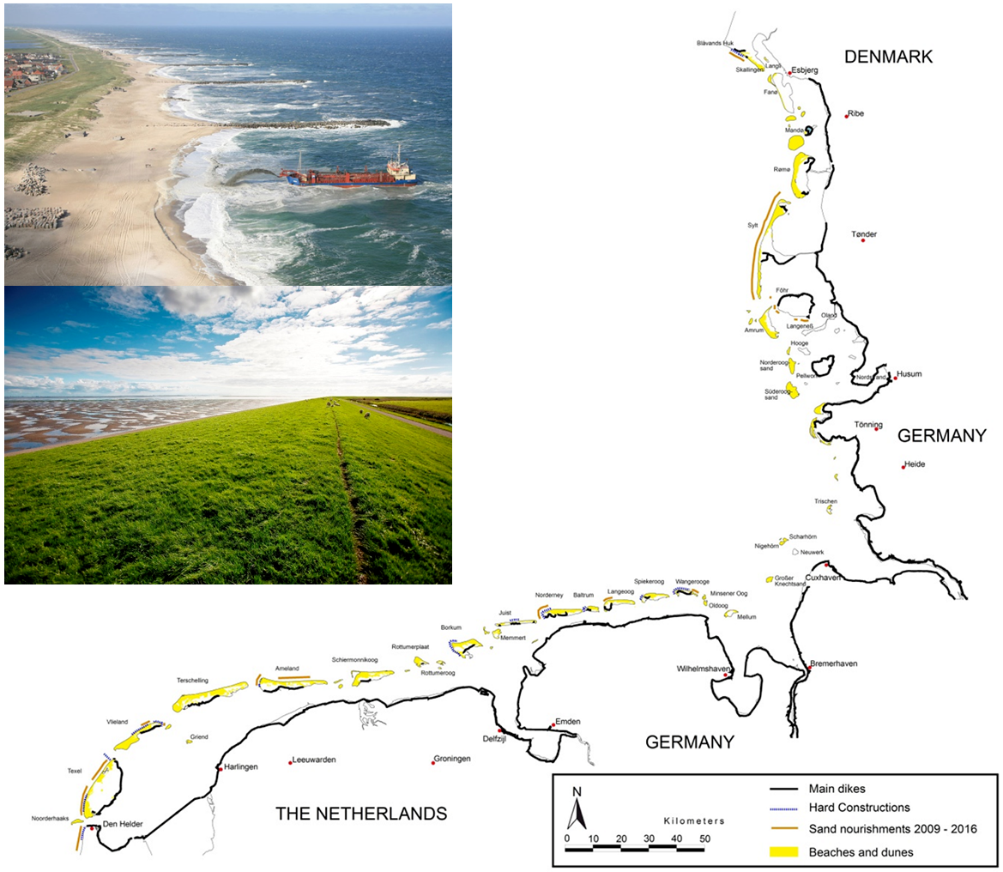 | Figure 5.5-1: Coastal flood defences and coastal protection works (map: CWSS). Photos: Upper left: groins / hard construction and sand nourishment in Denmark (Photo: Hunderup Luftfoto/ DKI); Lower left: typical ‘green’ Wadden Sea dike (Photos: Wetterskip Fryslân). Source: Zijlstra et al 2017. UPDATE & ADAPT FIGURE .

A detailed inventory per country can be developed and included in an online version (example see Table 1 next page).

Table 1. First draft of facts on Coastal flood defences and coastal protection works in the Wadden Sea.
EG-C: this table is open for suggestions and a fact check. Please keep brief!
 | Denmark | Schleswig-Holstein | Hamburg | Lower Saxony | Netherlands
Surface area (< +5m above mean sea level) in the coastal flood-prone lowlands in the Wadden Sea region [km²] (CPSL, 2010) | 600 | 3404 | 270 | 6,600 | 6,294
number of inhabitants in the coastal flood-prone lowlands in the Wadden Sea region CPSL, 2010 | 100,000 | 250,000 | 180,000 | 1,200,000 | 1,250,000
Total length of dikes [km]  QSR 2017 | 80 (mainland) | 263 (State dikes) | ?? none? | 645 (primary dikes) | About 430
Sand nourishment [m³/year] | <100.000 (Skallingen only) | ~1.4 million  (figures 2009-2015) | ?? none? | ~300.000  (figures 2009-2016) | ~ 3.5 million  (figures 2009-2015)
Responsibility dikes | Municipalities, local dike boards | State government?  Water boards?  Municipalities? | State government?  Water boards?  Municipalities? | State government?  Water boards?  Municipalities? | Rijkswaterstaat, water boards
Responsibility coastline | Coastal authority, municipalities | State government?  Water boards?  Municipalities? | State government?  Water boards?  Municipalities? | State government?  Water boards?  Municipalities? | Rijkswaterstaat

Common ground and legislation
The basis of coastal flood defence and coastal protection measures lie in national laws and policies. Depending on the regional situation responsibilities are delegated to regional or local authorities such as water boards or municipalities. All national legislation has to comply with the EU Floods directive that is effective since 2007. The EU Flood Directive gives a frame for assessment and management of flood risks. Menber States should undertake a preliminary assessment of flood risks and identify areas with a potential significant flood risk including climate change aspects for each or each river basin district by end of 2011. Further, for these areas, flood hazard and flood risk maps should be drawn up by the end of 2013, and flood risk management plans should be in place by the end of 2015 (CPSL, 2010).
Within the trilateral cooperation the focus is on ensuring that measures for Coastal flood defence and flood protection have minimal (negative) impact on the goals for the World Heritage site, and if possible strengthen or support goals. In three trilateral agreements this is described:
- The Wadden Sea Plan 2010:
7.1 Trilateral policies will be based on an integrated approach to coastal flood defence and protection and nature protection on the mainland coast, the islands and the offshore zone.
7.2 In view of accelerating sea level rise, increased attention will be given to the role of the offshore zone in the total Wadden Sea sand balance. In this respect sand will only be extracted from outside the Wadden Sea Area. Exemptions for local coastal flood defence and protection measures may be granted, provided it is the Best Environmental Practice for coastal protection (e.g. taking the sand from below the wave base).
- Statement from the WH Nomination Dossier 2008 (page 105).
The current level of protection will not be compromised under any foreseeable circumstances.
The current line and system of coastal flood defence and protection will be maintained and no further embankment will be undertaken in any parts of the nominated property in the foreseeable future. Aim is to keep the local impacts within a temporary timescale. The current and future flood defence standards demand, however, continuous reinforcement and adaptation of future coastal protection measures to rising sea level. This cannot be done without impacting the nominated property.
Reinforcement of the existing dikes will be carried out on the dikes. The use of sand for sea defence purposes will be combined as far as possible with the maintenance dredging of the shipping lanes. Coastal protection on the islands within the nominated property will be done by sand nourishment for the offshore area, which is the most environmentally friendly and most efficient solution for stabilizing eroding coasts.
- Climate Change Adaptation Strategy (CCAS) (Tønder Declaration, 2014).
The overall aim of climate change adaptation in the Wadden Sea region is to safeguard and promote the qualities and the integrity of the area as a natural and sustainable ecosystem whilst ensuring the safety of the inhabitants and visitors, as well as the cultural heritage and landscape assets and sustainable human use. The aim of the climate adaptation strategy is enhance and promote policies and measures necessary for increasing the resilience of the Wadden Sea to impacts of climate change. The strategy focuses on the Wadden Sea Area and the adjacent offshore and mainland areas as far as directly relevant for the implementation of seven the basic elements of the strategy. The strategy introduces seven principles for working on climate change adaptation in / near the Wadden Sea.
These agreements are backed up by law in the three countries (Table 1).
-> RZ: maybe agreements are, but this does not hold for the contents. E.g. in the Neterlands we do not use dredged material for nourishment or dikes, but we keep it in the system…. Skip this? -> this is the case in many topics. - SL Precisely part of the added value of the SIMP is to collect those different management approaches to implement the trilateral agreements. Managers as well as organisations on the policy level from the three countries want to have an exchange of experiences, preliminary results and lessons learned from the different ways of management. Is it possible to collect and document this in the EG-C? I can help if needed. then we do need to collect the approaches in more detail…
Table 2. Overview of laws and main policy documents for coastal defence, spatial planning and nature protection (include?) which backs up trilateral agreements in Denmark, in the three German Federal States and the Netherlands. Sources Zijlstra 2017 (QSR), CPSL 2010.
Wadden Sea World Heritage property in… | Coastal defence | Spatial planning | ??Nature protection??
All | EU Floods Directive* | European Spatial Development Perspective (ESDP) (not legally binding); | EU Habitat-,& Birds Directives (Natura2000), EU Water framework
…the Netherlands | Water Law 2009, National Water Plan, Deltalaw and Deltaprogramme, | Structure vision for the Wadden Sea (former PKB); Nationale omgevingsvisie (NOVI), Provinciale omgevingsvisies (POVI) | Natura 2000 management plans
Germany |  | Federal Spatial Planning Act;  Federal Building Act. | Federal Nature Protection Law;
Lower Saxony | Lower Saxony Dike Act | State Planning Programme (SPP); egional Planning Programmes (RPP) (both no legal frameworks?) | Lower Saxon Nature Conservation Act and the State National Park Act
Hamburg | ? | ? | National Park Act
Schleswig-Holstein | State Water Act | State Planning Act of Schleswig-Holstein | State Nature Conservation Act and the National Park Act
Denmark | EU Floods Directive*  Coastal Protection Act | National Planning Directives | Nature and Wildlife Reserve Executive Order; Executive Order on the Demarcation and Administration of International Nature Protection Areas;  Federal Nature Conservation Act,  Danish Statutory Order?
*defined potential significant flood risk areas and that flood risk management plans be established. Flood hazards maps must delineate risk areas that can be potentially flooded with low, medium and high probability. This information helps spatial planners to take flood risk into consideration in spatial plans.

Challenges
Climate change
Due to climate change the sea level is rising. In the future the sea level may rise more quickly (see IPCC-SROCC). This may lead to an increase of activities in the field of coastal protection, such as dike strengthening and sand nourishments. As a consequence pressures on the Wadden sea ecosystem and conflicts of interest may increase. One of the threats is that the demand for space increases and the Wadden Sea is further reduced in size.

Integral approach and cooperation
Coastal risk management can conflict with goals of the world heritage site. However, coastal protection can also offer opportunities. Activities like dike strengthening require major investments at the edge of the site. It is the challenge to cooperate between organisations involved in managing the world heritage site and coastal protection. By working via an integral approach the need for coastal risk management and their major investments may also lead to an improved situation for nature or other functions. For instance by combining dike improvements with nature development, also in the hinterland outside the Property.

Awareness of world heritage
Although many activities of coastal protection formally take place outside the Property, the bigger picture is that the quality of the social, economic and ecological systems of the Wadden sea depend on the quality of the boundaries and the hinterland of these systems too. It is the challenge to continue to raise awareness of working close to the world heritage site with parties working there. They are able to minimise the impact of their activities and sometime can even contribute to goals of the Property. If these parties, such as municipalities and water board are well aware of what they can do and are stimulated to further integrate the interests of the world heritage site into their daily work, also outside their formal responsibilities, opportunities for the Property can be seized .

The way forward
The trilateral cooperation is facing quite some challenges for the Property given climate change sea level rise and temperature increase. Via the present trilateral agreements, this plan and future trilateral agreements and by close cooperation, the future of the Wadden sea can ensured

References
CPSL, 2010. CPSL Third Report. The role of spatial planning and sediment in coastal risk management. Wadden Sea Ecosystem No. 28. Common Wadden Sea Secretariat, Trilateral Working Group on Coastal Protection and Sea Level Rise (CPSL), Wilhelmshaven, Germany
CPSL, 2005. Coastal Protection and Sea Level Rise - Solutions for sustainable coastal protection in the Wadden Sea region. Wadden Sea Ecosystem No. 21. Common Wadden Sea Secretariat, Trilateral Working Group on Coastal Protection and Sea Level Rise (CPSL), Wilhelmshaven, Germany
WH Nomination Dossiers http://whc.unesco.org/uploads/nominations/1314ter.pdf
Zijlstra R., Hofstede J.L.A., Piontkowitz T. & Thorenz F. (2017) Coastal Risk Management. In: Wadden Sea Quality Status Report 2017. Eds.: Kloepper S. et al., Common Wadden Sea Secretariat, Wilhelmshaven, Germany. Last updated 21.12.2017. Downloaded 202016. qsr.waddensea-worldheritage.org/reports/coastal-risk-management

Annex: Draft table of content of the Single Integrated Management Plan

Preface/Foreword
1. Introduction
  - The purpose of the SIMP
  - The scope
  - The added value
  - The challenges beyond the SIMP
2. The Outstanding Universal Value of the Wadden Sea
2.1. The OUV: Criteria
2.2. The OUV: Integrity
2.3. The OUV: Management requirements
3. The process of developing the SIMP
4. Management overview
4.1. Management cycle
4.2. National management systems
4.3. Trilateral cooperation structure
5. What to manage (key topics)
5.1. Fisheries
5.2. Tourism
5.3. Shipping
5.4. Renewable energy and Energy from oil and gas
5.5. Coastal and flood defence and protection
6. Roles and responsibilities (management implementation)
7. Means to support management
7.1. Communication
7.2. Education
7.3. Monitoring
7.4. Research
7.5. Knowledge management
7.6. Partnerships
8. Global dimensions
9. Monitoring and review of the SIMP
10. Resources, joint present and future projects
11. Abbreviations
12. References

OUV key values are directly derived from the Statement of OUV of the Wadden Sea World Heritage Property. These key values are also being applied in the Climate Vulnerability Index (CVI).

